Chapter 1
Introduction
In today’s digital world, data plays an important role in almost every field such as business, finance, healthcare, education, and research. Large amounts of data are generated daily, but understanding raw datasets manually is difficult and time-consuming. Because of this, modern analytics systems and visualization tools are widely used to convert complex numerical data into simple and meaningful visual insights through dashboards, charts, and reports.
Interactive analytics dashboards help users analyze information more effectively compared to traditional spreadsheets or static reports. These dashboards allow users to explore data dynamically using filters, graphs, and comparative visualizations. Business Intelligence tools such as Power BI make it easier to identify trends, compare datasets, and generate useful insights from large volumes of information.
One important area where analytics is highly useful is the study of global income distribution and economic inequality. Different countries experience variations in income levels, economic growth, and living standards. Understanding these differences helps researchers, economists, and policymakers study poverty, wealth distribution, and financial imbalance across different regions. Economic indicators such as GDP per capita, Gini Index, and income share are commonly used to analyze these patterns.
The project titled “Interactive Analytics Dashboard for Global Income Distribution” was developed to simplify the analysis of global economic data through a full-stack web-based analytics platform. The system combines frontend development, backend processing, database management, and interactive visualization into a single platform that helps users explore economic data more efficiently.
The frontend of the application is developed using HTML, CSS, and JavaScript to create a responsive and user-friendly interface. Python is used for backend processing and data handling, while SQLite is used for database management. Power BI is integrated into the system to provide interactive dashboards and visual analytics. Additional libraries such as Pandas and NumPy are used for data preprocessing, cleaning, and transformation.
The platform allows users to compare countries, analyze regional economic patterns, and study income inequality using interactive charts and filters. The project was developed during the Infosys Springboard Virtual Internship program, which provided practical exposure to full-stack web development, data analytics, dashboard integration, and visualization technologies. This project helped improve technical skills and provided real-world experience in developing interactive analytics systems and web-based data visualization platforms.
1.1 Introduction to Global Income Distribution
Global income distribution refers to the way income and wealth are shared among people, countries, and different regions around the world. Some countries have strong economies and high living standards, while others face poverty, unemployment, and limited financial resources. Because of these differences, the distribution of income is not equal across the world. Studying global income distribution helps researchers, economists, and policymakers understand economic inequality and identify regions that require financial and developmental support.
Economic indicators such as GDP per capita, Gini Index, income share, and poverty ratio are commonly used to measure income inequality and economic growth. These indicators help in understanding how wealth is distributed among populations and how economic conditions change over time. By analyzing these datasets, governments and organizations can make better decisions related to economic planning, social welfare, and development policies.
In recent years, the amount of global economic data available from organizations such as the World Bank, IMF, and OECD has increased significantly. However, these datasets are often large and difficult to analyze manually. Traditional reports and spreadsheets usually contain complex numerical information that is not easy for users to understand quickly. Because of this, interactive analytics and visualization systems have become important for simplifying economic analysis.
The Interactive Analytics Dashboard for Global Income Distribution project focuses on transforming complex global economic data into meaningful visual insights using interactive dashboards and analytical tools. The system helps users compare countries, study regional economic patterns, analyze income inequality, and understand long-term financial trends through charts, filters, and graphical reports. This makes economic data more understandable, accessible, and useful for research and analysis purposes.

1.2 Need for the Project
In today’s world, large amounts of economic and financial data are generated by different countries and international organizations every year. This data contains important information related to income levels, poverty, GDP growth, employment, and wealth distribution. Although this information is publicly available, understanding and analyzing it manually is difficult because the datasets are large, complex, and spread across multiple sources. Traditional methods such as spreadsheets, tables, and static reports often make data analysis time-consuming and less interactive for users.
Many existing systems provide economic data only in numerical or textual format, which makes it difficult for users to identify patterns, compare countries, or study long-term trends efficiently. Users often struggle to understand income inequality and economic differences between regions because the available reports do not provide proper visualization and interactive analysis features. As a result, researchers, students, and analysts require a more user-friendly system that can present economic information in a simple and visually understandable manner.
Another major challenge is the lack of integrated platforms that combine data preprocessing, visualization, and interactive analytics within a single system. Most existing solutions focus only on displaying reports without allowing users to explore data dynamically using filters, comparisons, and graphical insights. This creates limitations in understanding global income distribution effectively.
The “Interactive Analytics Dashboard for Global Income Distribution” project was developed to solve these problems by creating a full-stack web-based analytics platform capable of transforming raw economic data into interactive visual insights. The system allows users to analyze global income distribution through charts, dashboards, and comparative analytics. By integrating frontend technologies, backend processing, database management, and Power BI visualization, the project provides an easier and more effective way to understand economic inequality and global financial trends.
1.3 Company Profile

Fig 1.1: Company Logo
As shown in Figure 1.1, the Infosys Springboard logo represents the digital learning and skill development platform provided by Infosys to support students and learners through technology-based education, training, and industry-oriented programs.The rapid growth of information technology has transformed the way organizations operate and manage their business activities. Modern industries depend heavily on software solutions, digital systems, cloud platforms, Artificial Intelligence, and data analytics to improve productivity and decision-making processes. Technology companies play an important role in developing these solutions and supporting digital transformation across different sectors. Among these companies, Infosys Limited is recognized as one of the leading global organizations in the field of information technology and consulting services.
Infosys is a multinational technology company that provides services in software development, digital transformation, cloud computing, data analytics, Artificial Intelligence, cybersecurity, engineering solutions, and business consulting. Since its establishment, the company has continuously focused on innovation and advanced technological solutions that help organizations improve their operational efficiency and digital capabilities. Infosys has built a strong reputation globally by delivering high-quality IT services and supporting businesses in adapting to modern technological changes.
Apart from providing business and software solutions, Infosys also contributes significantly toward technical education and skill development for students and professionals. The company supports learning initiatives that help students gain practical exposure to industry-oriented technologies and real-world project implementation. To promote this vision, Infosys introduced the Infosys Springboard platform, which provides learning resources, certification programs, and virtual internship opportunities in different technology domains.
1.3.1 Introduction to Infosys
Infosys Limited is one of the world’s leading information technology companies, established in 1981 with the aim of delivering software services and innovative technology solutions. Over the years, the company has expanded its operations globally and now provides services to organizations from various industries including banking, healthcare, education, retail, manufacturing, and telecommunications. Infosys is known for its focus on innovation, digital transformation, and advanced software engineering solutions.
The company works in multiple technology domains such as web development, cloud computing, Artificial Intelligence, Machine Learning, cybersecurity, business intelligence, enterprise solutions, and data analytics. Infosys helps organizations modernize their systems, improve productivity, and adopt digital technologies for better business performance. The company also emphasizes research and development to continuously improve technological innovation and provide advanced IT solutions for modern business challenges.
Infosys strongly supports education and technical skill development through different learning programs and training initiatives. The company provides opportunities for students and young professionals to gain practical knowledge related to software development, programming, analytics, and modern digital technologies. Through its educational initiatives and technology-focused environment, Infosys has become one of the most respected organizations in the global IT industry.
1.3.2 Infosys Springboard Virtual Internship
Infosys Springboard is a digital learning and virtual internship platform launched by Infosys with the objective of helping students improve their technical and professional skills. The platform provides free access to online courses, certification programs, coding practice sessions, project-based learning, and internship opportunities in different technology fields. It is designed to reduce the gap between academic learning and practical industry requirements by providing hands-on experience through real-world projects.
The Infosys Springboard Virtual Internship program allows students to work on projects related to technologies such as web development, Python programming, data analytics, Artificial Intelligence, cloud computing, cybersecurity, and business intelligence. Through these internships, students gain practical exposure to software development workflows, analytical systems, visualization tools, and modern implementation techniques used in the IT industry.
The “Interactive Analytics Dashboard for Global Income Distribution” project was developed during the Infosys Springboard Virtual Internship program. This internship provided practical experience in full-stack web development, data preprocessing, database management, dashboard integration, and analytics visualization. The project also helped improve technical understanding of HTML, CSS, JavaScript, Python, SQLite, Power BI, and data analytics technologies.
Working on this project provided valuable experience in designing interactive web applications, handling economic datasets, integrating dashboards, and implementing analytical workflows. The internship also improved problem-solving skills, technical confidence, project management understanding, and practical exposure to real-world software development processes.
1.3.3 Internship Domain
The internship was carried out in the domain of Data Analytics and Full-Stack Web Development. This domain focuses on collecting, processing, analyzing, and visualizing data using modern software technologies and web-based systems. In today’s digital environment, organizations rely heavily on analytics platforms and visualization tools to understand business trends, financial conditions, customer behavior, and operational performance. Because of this, data analytics and interactive dashboard systems have become highly important in modern software development and decision-making processes.
The project combined multiple technical areas including frontend development, backend programming, database management, and business intelligence visualization. Frontend technologies such as HTML, CSS, and JavaScript were used to design responsive and interactive user interfaces, while Python was used for backend processing, data handling, and analytical operations. SQLite was used as the database management system for storing and managing project-related information efficiently.
The internship domain also involved the use of Business Intelligence and visualization technologies such as Power BI for creating interactive dashboards and analytical reports. Power BI helped transform raw economic datasets into visual insights through graphs, charts, filters, and comparative analytics. Data preprocessing and transformation were performed using Python libraries such as Pandas and NumPy to clean and organize datasets before visualization.
Working in this domain provided practical knowledge of full-stack application development, analytics system design, dashboard integration, database handling, and visualization techniques. The internship helped in understanding how modern analytical web applications are developed and how different technologies work together to create interactive and user-friendly analytics platforms.
1.4 Problem Statement
In today’s world, large amounts of economic and financial data are generated by governments, research organizations, and international institutions such as the World Bank, IMF, and OECD. These datasets contain important information related to income distribution, GDP growth, poverty levels, employment statistics, and economic inequality across different countries and regions. Although this information is publicly available, analyzing and understanding it manually becomes difficult because the datasets are large, complex, and continuously growing.
Most existing systems present economic information in the form of spreadsheets, reports, tables, or static charts, which makes data interpretation difficult for users. Comparing multiple countries, identifying regional inequality patterns, and analyzing long-term economic trends requires significant manual effort and technical understanding. Traditional analytical methods often fail to provide proper interactivity and dynamic visualization features that help users explore data more efficiently.
Another major issue is that many available systems focus only on displaying data instead of providing meaningful visual insights and interactive analysis. Users often face difficulties while filtering datasets, comparing economic indicators, and understanding the relationship between different financial parameters. As a result, economic analysis becomes time-consuming and less effective for researchers, students, analysts, and policymakers.
There is also a lack of integrated web-based platforms that combine frontend interaction, backend processing, database management, and business intelligence visualization within a single system. Most systems either provide only visualization or only data storage functionalities without offering a complete interactive analytics environment. Because of this limitation, users are unable to perform smooth and efficient analysis of global income distribution data.
To overcome these problems, the “Interactive Analytics Dashboard for Global Income Distribution” project was developed as a full-stack analytics web application capable of transforming complex economic datasets into interactive visual insights. The system combines frontend technologies, backend processing, SQLite database management, and Power BI integration to provide users with a user-friendly platform for analyzing global income inequality and economic trends through dynamic charts, dashboards, and interactive analytics features.
1.5 Proposed Solution
To overcome the limitations of traditional economic analysis systems, the project “Interactive Analytics Dashboard for Global Income Distribution” was developed as a full-stack web-based analytics platform capable of transforming complex economic datasets into interactive visual insights. The proposed system focuses on simplifying the analysis of global income distribution and economic inequality through advanced visualization techniques, interactive dashboards, and user-friendly web interfaces.
The system combines frontend technologies, backend processing, database management, and business intelligence tools within a single integrated platform. The frontend of the application is developed using HTML, CSS, and JavaScript to provide a responsive and interactive user interface that allows users to navigate the platform easily and access different analytical features smoothly. The backend processing is implemented using Python, which handles data processing, dataset management, analytical operations, and communication between system components efficiently.
SQLite is used as the database management system for storing and organizing project-related data in a structured manner. The database helps manage datasets, analytical records, and system operations more effectively. In addition, Python libraries such as Pandas and NumPy are used for data cleaning, preprocessing, transformation, and organization before visualization. These preprocessing operations improve the accuracy, consistency, and quality of the data used in the analytics system.
One of the major components of the proposed solution is the integration of Power BI dashboards for interactive data visualization and business intelligence analytics. Power BI helps convert raw economic datasets into understandable charts, graphs, comparative reports, and analytical dashboards. Users can interact with the dashboard dynamically using filters, country selectors, and comparative analytics features to study regional economic patterns and global income inequality more efficiently.
The developed platform allows users to compare countries, analyze GDP growth, study income distribution patterns, and understand long-term economic trends through interactive visualizations. Instead of relying on static spreadsheets and reports, users can explore data dynamically and generate meaningful insights more easily. The system is designed to improve accessibility, simplify economic analysis, and provide a better understanding of global financial conditions through visual and interactive analytics.

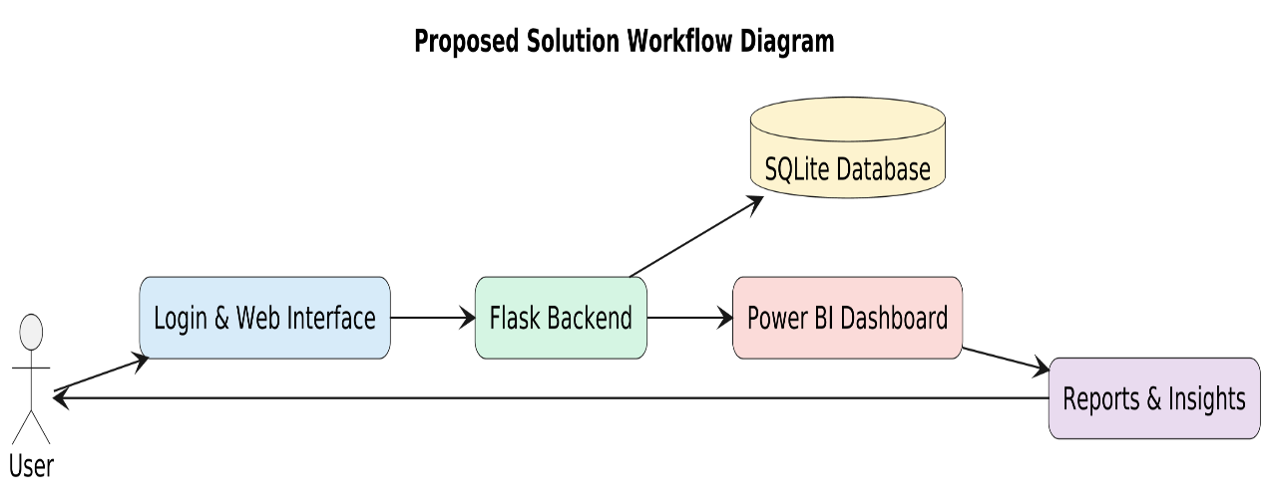
Fig 1.2: Proposed Solution Workflow Diagram
Above Fig 1.2 shows the proposed solution workflow of the GIDA platform, where user requests are processed through the web interface, Flask backend, SQLite database, and Power BI dashboard to generate interactive analytical reports and insights.The proposed solution also focuses on scalability and flexibility, allowing future improvements such as real-time data integration, Artificial Intelligence-based prediction systems, cloud database support, and advanced analytical features. Overall, the system provides a modern, user-friendly, and efficient solution for analyzing global income distribution using full-stack web technologies and business intelligence visualization tools.
1.6 Objectives of the Project
The main objective of the “Interactive Analytics Dashboard for Global Income Distribution” project is to develop a full-stack web-based analytics platform capable of analyzing and visualizing global economic data in an interactive and user-friendly manner. The project aims to simplify the understanding of income inequality and economic distribution by transforming large and complex datasets into meaningful visual insights through dashboards, charts, and comparative analytics.
One of the primary objectives of the project is to collect and organize global economic datasets from reliable sources such as the World Bank, IMF, and OECD. These datasets contain important economic indicators related to GDP per capita, Gini Index, poverty ratio, income share, and regional financial trends. The project focuses on managing these datasets efficiently so they can be used for accurate analysis and visualization.
Another important objective is to preprocess and clean the collected data before visualization. Since economic datasets often contain missing values, inconsistent records, and formatting differences, the project aims to improve data quality through cleaning, transformation, normalization, and organization techniques using Python libraries such as Pandas and NumPy. Proper preprocessing helps improve the reliability and accuracy of the analytical results generated by the system.
The project also aims to develop a responsive and interactive frontend interface using HTML, CSS, and JavaScript. The objective of the frontend design is to provide users with a simple, attractive, and user-friendly environment where they can explore analytical dashboards and interact with visual data easily. The interface is designed to improve user experience and simplify navigation within the platform.
Another major objective of the project is to integrate Power BI dashboards into the web application for advanced business intelligence visualization. The project focuses on presenting global income distribution data through interactive charts, graphs, filters, and comparative reports that allow users to analyze countries, regions, and economic trends dynamically. This helps users understand economic inequality more effectively compared to traditional static reports and spreadsheets.
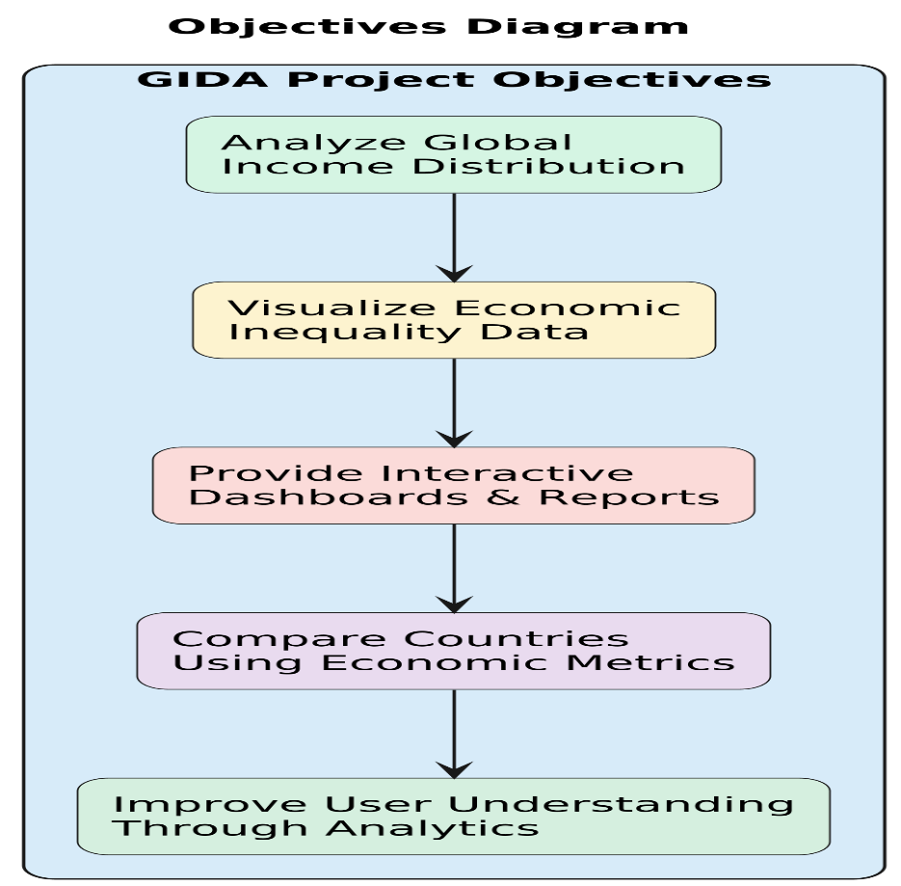
Fig 1.3: Objectives Diagram
Above Fig 1.3 shows the objectives of the GIDA project, including analyzing global income distribution, visualizing economic inequality data, providing interactive dashboards and reports, comparing countries using economic metrics, and improving user understanding through analytics.The project also aims to implement backend processing and database management using Python and SQLite. Backend operations help manage data processing, analytics workflows, and communication between different system components, while SQLite provides structured data storage and efficient database management for handling project-related information.
An additional objective of the project is to improve analytical understanding and decision-making by providing meaningful visual insights related to global income distribution. The system helps users compare countries, study regional economic patterns, analyze inequality indicators, and identify long-term financial trends through interactive visualization features.
Apart from technical implementation, the project also aims to provide practical exposure to full-stack web development, data analytics, business intelligence tools, and dashboard integration technologies. The project was developed as part of the Infosys Springboard Virtual Internship program, which helped enhance technical knowledge, problem-solving skills, and practical understanding of modern analytics platform development.
1.7 Scope of the Project
The scope of the “Interactive Analytics Dashboard for Global Income Distribution” project mainly focuses on developing a full-stack web-based analytics platform for analyzing and visualizing global economic and income distribution data in an interactive manner. The system is designed to help users understand economic inequality, financial distribution, and regional economic patterns through dashboards, charts, and comparative analytics. The project provides a user-friendly environment where complex economic datasets can be explored more easily using interactive visualization techniques.
The project covers the collection and preprocessing of global economic datasets obtained from reliable sources such as the World Bank, IMF, and OECD. These datasets include information related to GDP per capita, Gini Index, poverty ratio, income share, and other important economic indicators. The system processes and organizes these datasets to improve data quality and prepare them for analytical operations and visualization.
Another important scope of the project is the development of a responsive frontend interface using HTML, CSS, and JavaScript. The web interface allows users to interact with the analytics platform smoothly and access visualization features in a simple and understandable way. Backend processing and data management are implemented using Python and SQLite, which help manage datasets, analytical operations, and database handling efficiently.
The project also includes the integration of Power BI dashboards for business intelligence visualization and interactive reporting. Through Power BI integration, users can compare countries, analyze regional economic conditions, study income inequality trends, and observe financial patterns using dynamic charts and filters. The platform is designed to simplify economic analysis and provide meaningful insights through visual representation of data.
The scope of the project further extends to educational and research purposes, where students, analysts, and researchers can use the system for understanding economic indicators and global financial conditions more effectively. The platform can also support future enhancements such as real-time data integration, cloud database connectivity, predictive analytics, Artificial Intelligence-based forecasting, and advanced analytical modules. Overall, the project provides a strong foundation for developing modern interactive analytics systems using full-stack web technologies and business intelligence tools.

Chapter 2
System Architecture
The system architecture of the “Interactive Analytics Dashboard for Global Income Distribution” project is designed to provide a structured and efficient environment for processing, managing, and visualizing global economic data. The architecture combines frontend development, backend processing, database management, and business intelligence visualization into a single integrated platform. The main purpose of the architecture is to ensure smooth communication between different components of the system while providing users with interactive analytics and meaningful visual insights.
The developed system follows a full-stack web application architecture where different technologies work together to perform data collection, preprocessing, storage, visualization, and user interaction. The frontend part of the system is developed using HTML, CSS, and JavaScript, which are responsible for designing the user interface and improving user interaction with the application. The frontend allows users to navigate through the website, access dashboards, apply filters, and analyze different economic indicators through an interactive and responsive environment.
The backend architecture is implemented using Python, which handles data processing, preprocessing operations, analytical workflows, and communication between the frontend and database components. Python plays an important role in managing datasets, transforming raw economic data into structured formats, and supporting analytical functionalities required by the system. Backend processing also ensures smooth handling of user requests and dashboard integration within the platform.
The database architecture of the project is managed using SQLite. The database stores project-related datasets, processed information, and analytical records in a structured manner. SQLite helps maintain efficient data management and allows the system to retrieve and update information whenever required. The use of a lightweight database system makes the application simpler, faster, and easier to manage for analytical operations.
One of the most important components of the architecture is the integration of Power BI dashboards for interactive business intelligence visualization. Power BI is used to convert large and complex economic datasets into understandable charts, graphs,
comparative reports, and analytical dashboards. These dashboards allow users to interact dynamically with the data by selecting countries, regions, and economic indicators using filters and visualization controls. This helps users understand global income distribution and economic inequality more effectively compared to traditional reporting methods.
The system architecture also includes a data preprocessing layer where raw datasets collected from sources such as the World Bank, IMF, and OECD are cleaned and transformed before visualization. Python libraries such as Pandas and NumPy are used for handling missing values, formatting inconsistencies, normalization, and data organization. Proper preprocessing improves the quality and reliability of the datasets used for analysis and dashboard generation.
The overall workflow of the system begins with dataset collection and preprocessing, followed by database storage and backend analytical processing. The processed data is then integrated into Power BI dashboards for visualization and displayed through the frontend web interface. Users interact with the system through the website, where they can analyze economic trends, compare countries, and study income inequality using interactive charts and graphical reports.
The modular architecture of the project improves scalability, flexibility, and maintainability of the system. Different components such as frontend modules, backend processing, database management, and visualization layers work independently while maintaining smooth communication with each other. This design approach makes it easier to upgrade the system and add future enhancements such as real-time data integration, cloud database support, predictive analytics, and Artificial Intelligence-based forecasting features.
Overall, the system architecture provides a complete framework for developing an interactive analytics platform capable of simplifying global economic analysis through full-stack web technologies, database systems, backend processing, and business intelligence visualization tools.
2.1 Overall Architecture of the System
The overall architecture of the “Interactive Analytics Dashboard for Global Income Distribution” project is designed to create an organized and efficient full-stack analytics platform capable of handling data processing, storage, visualization, and user interaction within a single system. The architecture combines frontend technologies, backend processing, database management, and business intelligence tools to provide users with an interactive environment for analyzing global economic and income distribution data.
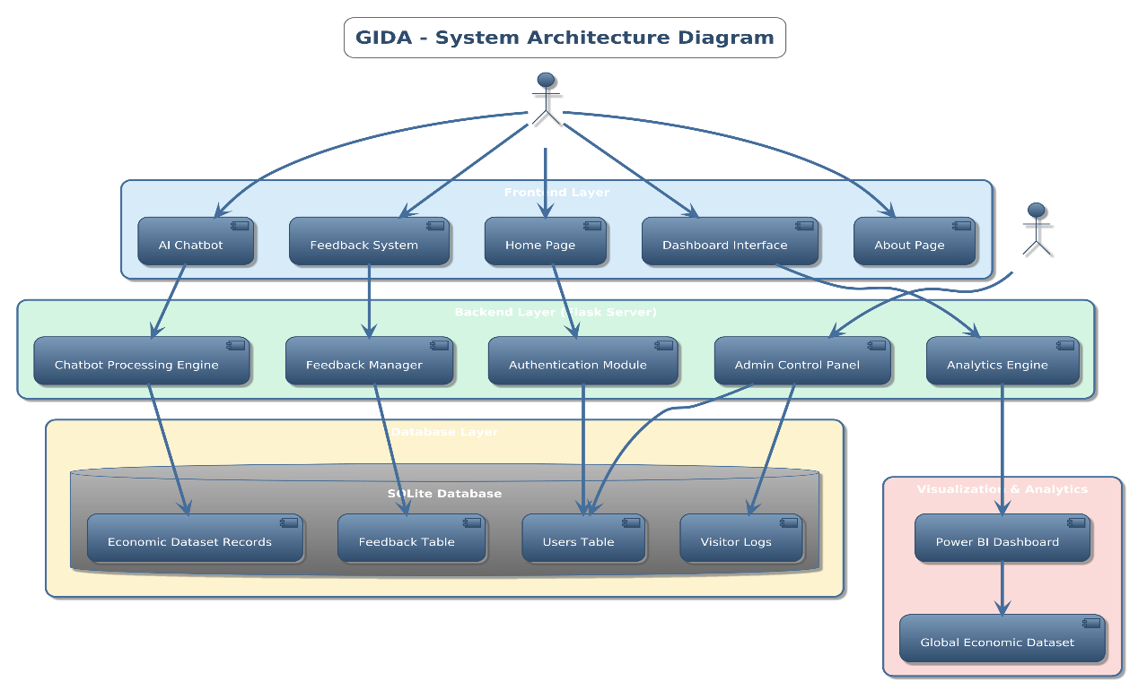
Fig 2.1: System Architecture Diagram
Above Fig 2.1 shows the overall system architecture of the GIDA platform, including the frontend interface, backend processing modules, database layer, and Power BI analytics integration working together to perform global income distribution analysis. The system architecture mainly consists of four major layers: the frontend layer, backend processing layer, database layer, and visualization layer. Each layer performs specific tasks while communicating with other components of the system to ensure smooth execution of analytical operations and dashboard functionalities.
The frontend layer is developed using HTML, CSS, and JavaScript. This layer acts as the user interaction component of the system and provides a responsive web interface through which users can access dashboards, apply filters, and explore economic analytics. HTML is used to design the structure of web pages, CSS is used for styling and improving visual appearance, while JavaScript provides dynamic interaction and user-side functionalities within the application. The frontend interface is designed to be simple, interactive, and user-friendly so that users can navigate the platform easily and understand analytical reports more effectively.
The backend processing layer is implemented using Python. This layer handles important operations such as data processing, analytical workflows, request handling, and communication between different system components. Python processes the economic datasets collected from multiple sources and performs operations such as cleaning, formatting, transformation, and data organization. Backend processing also helps in integrating the database with the frontend interface and ensures proper execution of analytics-related functionalities.
The database layer of the system is managed using SQLite. The database stores economic datasets, processed records, and project-related information in a structured format. SQLite helps manage data efficiently and supports fast retrieval and updating of information whenever required. The database layer plays an important role in maintaining data consistency and supporting analytical operations within the platform.
Another important component of the architecture is the visualization layer, which is implemented using Power BI dashboards. Power BI is integrated into the system to provide interactive business intelligence visualization and analytical reporting features. This layer converts processed datasets into visual insights through charts, graphs, comparative reports, and dashboards. Users can interact with the visualizations dynamically by selecting filters, countries, regions, and economic indicators to perform customized analysis and better understand global income distribution patterns.
The overall workflow of the architecture begins with data collection from sources such as the World Bank, IMF, and OECD. The collected datasets are then processed and cleaned using Python libraries such as Pandas and NumPy. After preprocessing, the organized data is stored in the SQLite database and further integrated with Power BI dashboards for visualization. The frontend interface displays these dashboards and allows users to interact with the analytics system through the web application.
The architecture is designed using a modular approach, which improves flexibility, scalability, and maintainability of the system. Each layer works independently while maintaining smooth communication with other modules. This structure allows future enhancements such as real-time data integration, Artificial Intelligence-based analytics, cloud database connectivity, and advanced forecasting systems to be implemented more easily.
Overall, the system architecture provides a complete framework for building an interactive analytics platform that simplifies the analysis of global economic data through full-stack web technologies, backend processing, database management, and business intelligence visualization tools.
2.2 Frontend Architecture
The frontend architecture of the “Interactive Analytics Dashboard for Global Income Distribution” project is designed to provide users with a responsive, interactive, and user-friendly web interface for accessing analytical dashboards and visual reports. The frontend acts as the communication layer between the user and the system, allowing users to interact with different features of the application smoothly and efficiently. The main objective of the frontend architecture is to create an organized and visually attractive environment where users can easily explore global economic data and analytical insights.
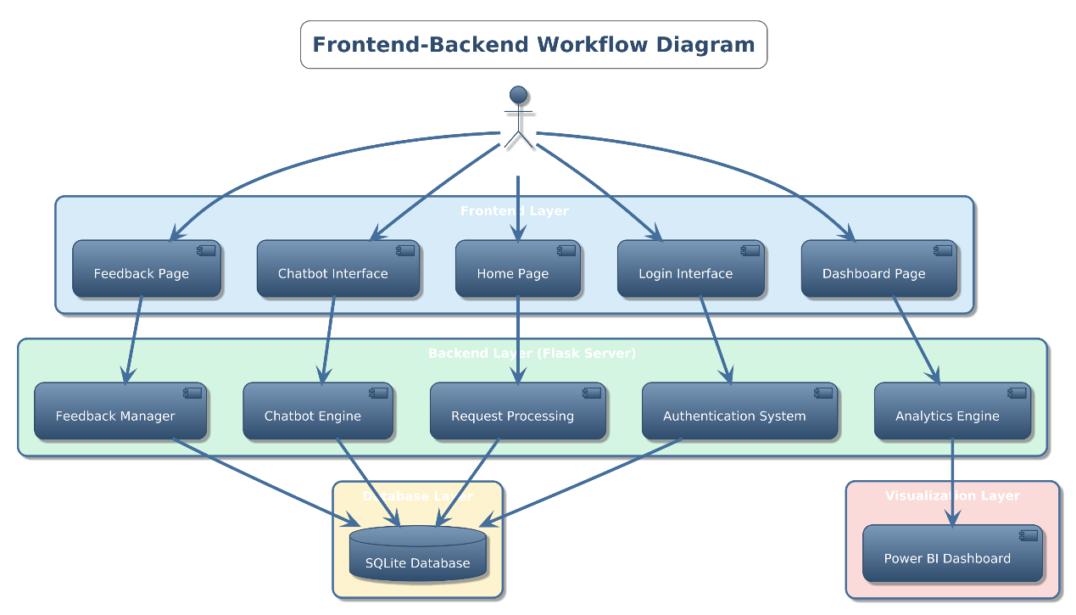
Fig 2.2: Frontend-Backend Workflow Diagram
Above Fig 2.2 shows the frontend–backend workflow of the GIDA platform, illustrating how user requests from the web interface are processed through the Flask backend, database system, and Power BI analytics dashboard. The frontend of the application is developed using HTML, CSS, and JavaScript. HTML is used to create the basic structure of the web pages and organize different sections of the interface such as navigation menus, dashboard containers, buttons, filters, forms, and content areas. It helps define the layout of the website and provides the foundation for displaying analytical information and visual components within the application.
CSS is used to improve the visual appearance and styling of the website. It helps design the layout, colors, fonts, spacing, alignment, and responsiveness of the user interface. The use of CSS makes the application visually attractive and ensures that the website maintains a professional appearance across different screen sizes and devices. Responsive design techniques are implemented to improve accessibility and provide better user experience on desktops, laptops, and other devices.
JavaScript is used to provide dynamic functionality and interactivity within the frontend system. It allows the application to respond to user actions such as selecting filters, navigating between pages, updating dashboards, and interacting with charts or visualization components. JavaScript improves the responsiveness of the platform by enabling real-time updates and smooth interaction between the frontend interface and backend processing modules.
The frontend architecture also includes navigation components that help users move easily between different sections of the application. Features such as dashboard pages, analytical reports, filters, and visualization modules are organized systematically to improve usability and simplify navigation. The interface is designed in a way that even non-technical users can understand and interact with the analytics platform without difficulty.
Another important part of the frontend architecture is the integration of Power BI dashboards into the web interface. The frontend provides a dedicated area for embedding interactive Power BI reports and dashboards, allowing users to view analytical charts, compare economic indicators, and study income distribution patterns directly from the website. Filters and visualization controls are integrated into the frontend so users can dynamically interact with the dashboards and generate customized analytical insights.
The frontend architecture is designed with a modular approach, where different interface components work independently while maintaining proper coordination with the backend system. This improves flexibility and makes it easier to update or enhance the user interface in the future. Additional features such as advanced visualization modules, responsive dashboards, and interactive controls can be integrated into the frontend architecture without affecting the overall system performance.
Overall, the frontend architecture plays an important role in improving user interaction, visual presentation, and accessibility of the analytics platform. By combining HTML, CSS, and JavaScript with interactive dashboard integration, the frontend provides a smooth and efficient environment for analyzing and visualizing global income distribution data through a modern web-based interface.

2.3 Backend Architecture
The backend architecture of the “Interactive Analytics Dashboard for Global Income Distribution” project is designed to manage the core processing and functional operations of the system. It acts as the central processing layer that handles data management, analytical operations, communication between system components, and integration of different technologies within the platform. The backend architecture plays an important role in ensuring that the application works smoothly and efficiently while handling large economic datasets and interactive analytics operations.
The backend of the system is developed using Python because of its simplicity, flexibility, and strong support for data processing and analytics-related applications. Python is used to perform operations such as data preprocessing, dataset management, backend logic implementation, request handling, and communication between the frontend interface, database system, and visualization modules. Its large collection of libraries and frameworks makes it suitable for building analytical and data-driven web applications.
One of the major responsibilities of the backend architecture is data processing and preprocessing. The system collects global economic datasets from different sources and processes them before visualization. Python libraries such as Pandas and NumPy are used for handling missing values, removing duplicate records, formatting datasets, performing normalization, and organizing the data into structured formats. These preprocessing operations help improve data consistency, reliability, and analytical accuracy within the system.
The backend architecture also manages communication between the frontend interface and the SQLite database. Whenever users interact with the platform, the backend processes the requests and retrieves the required information from the database. It ensures smooth data flow between different layers of the system and supports operations such as storing records, retrieving datasets, updating information, and handling analytical queries efficiently.
Another important function of the backend system is integrating Power BI dashboards with the web application. The backend helps manage the communication required for embedding dashboards and ensuring that analytical reports and visualization components are displayed correctly within the frontend interface. It also supports data synchronization and helps maintain smooth interaction between the analytics modules and the user interface.
The backend architecture is designed using a modular approach where different processing components work independently while remaining connected to the overall system. This structure improves maintainability, flexibility, and scalability of the application. Different backend modules such as data preprocessing, database operations, analytical processing, and dashboard integration can be modified or upgraded without affecting the complete system architecture.
Error handling and system management are also important parts of the backend architecture. The backend is responsible for detecting and handling issues related to data processing, database connectivity, invalid inputs, and system operations. Proper error handling mechanisms help improve the reliability and stability of the application and ensure smoother user experience during analytical operations.
The backend architecture also supports future enhancements and scalability. Since the system is built using Python and modular backend components, advanced features such as real-time data integration, Artificial Intelligence-based analytics, cloud database connectivity, and predictive modeling can be integrated more easily in future versions of the platform.
Overall, the backend architecture provides the core functionality required for processing economic datasets, managing system operations, supporting database communication, and integrating visualization tools within the analytics platform. By combining Python-based processing with database management and analytical operations, the backend creates a stable and efficient environment for developing a modern full-stack analytics web application.
2.4 Database Architecture
The database architecture of the “Interactive Analytics Dashboard for Global Income Distribution” project is designed to manage, organize, and store large amounts of economic and analytical data in a structured manner. The database plays an important role in maintaining data consistency, supporting backend operations, and enabling smooth retrieval of information required for analytics and visualization. A well-organized database system helps improve the efficiency, reliability, and performance of the overall application.
The project uses SQLite as the database management system because it is lightweight, simple to use, and suitable for web-based analytical applications. SQLite allows the system to store datasets, processed records, user-related information, and analytical data efficiently without requiring complex server configurations. Its lightweight architecture makes it ideal for handling project-level database operations while maintaining fast performance and easy integration with Python backend processing.
The database architecture is designed to store economic datasets collected from multiple sources such as the World Bank, IMF, and OECD. These datasets include important information related to GDP per capita, Gini Index, poverty ratio, income distribution, regional economic indicators, and other financial statistics. The data is organized into structured tables so that it can be managed and retrieved efficiently whenever required by the system.
The backend system communicates directly with the SQLite database to perform different operations such as data insertion, retrieval, updating, and processing. Python is used to manage database connectivity and execute SQL queries for handling analytical workflows. Whenever users interact with the platform and request specific analytics or visualizations, the backend retrieves the required data from the database and processes it for dashboard generation and reporting.
The database architecture also supports preprocessing and transformed datasets. After cleaning and organizing raw economic data using Python libraries such as Pandas and NumPy, the processed information is stored in the database in a structured format. This improves data consistency and ensures that the visualization layer receives accurate and reliable information for dashboard analytics.
Another important feature of the database architecture is efficient data management and organization. Different tables are used for storing country information, regional economic records, income distribution statistics, and processed analytical datasets. This structured organization helps reduce redundancy and improves the speed of analytical operations and data retrieval within the system.
The database system is also designed to support scalability and future enhancements. Additional datasets, analytical modules, or user-related functionalities can be added to the database architecture without major changes to the overall system structure. This flexibility allows future integration of cloud databases, real-time APIs, and advanced analytical features more easily.
Overall, the database architecture provides a stable and organized environment for managing economic datasets and supporting analytical operations within the platform. By integrating SQLite with Python backend processing and visualization modules, the system ensures efficient storage, retrieval, and management of global income distribution data for interactive analytics and reporting purposes.
2.5 Power BI Integration Architecture
The Power BI Integration Architecture of the “Interactive Analytics Dashboard for Global Income Distribution” project is designed to provide interactive business intelligence visualization and analytical reporting within the web application. Power BI acts as the main visualization component of the system and helps transform complex economic datasets into understandable graphical insights through dashboards, charts, reports, and comparative analytics. The integration architecture ensures smooth communication between the processed datasets, backend system, and visualization layer so that users can interact with analytical information efficiently.
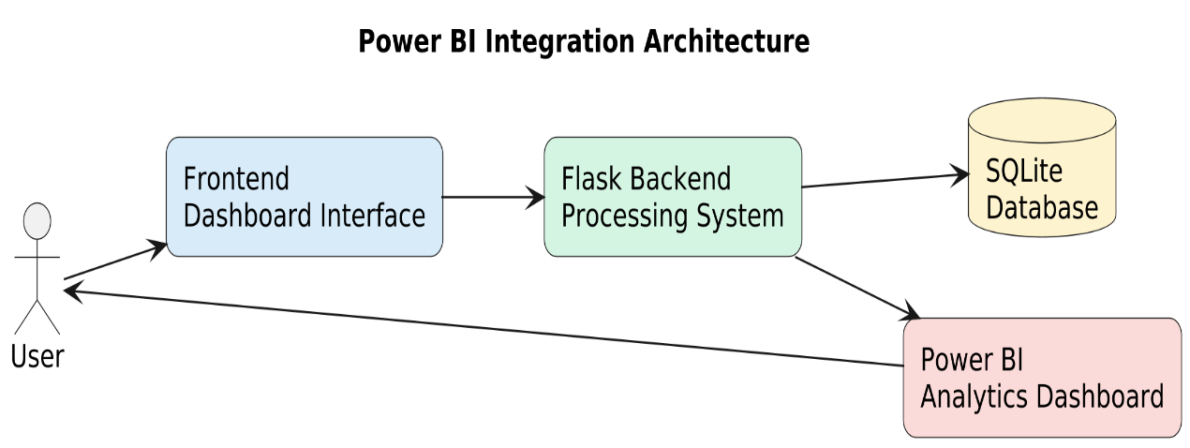
Fig 2.3: Power Bi Integration Architecture
Above Fig 2.3 shows the Power BI integration architecture of the GIDA platform, where the frontend dashboard communicates with the Flask backend, SQLite database, and Power BI analytics dashboard to provide interactive economic data visualization and analysis. The integration process begins after the economic datasets are collected, cleaned, and processed through the backend system. Python libraries such as Pandas and NumPy are used to preprocess the raw data and organize it into structured formats suitable for analysis and visualization. Once the datasets are properly prepared, they are connected with Power BI for dashboard creation and report generation.
Power BI is used to design interactive dashboards that visually represent global income distribution and economic indicators. Different types of visualizations such as bar charts, line graphs, pie charts, heatmaps, and comparative reports are created within the Power BI environment. These visual components help users analyze country-wise income distribution, compare regional economic conditions, study inequality patterns, and observe long-term financial trends more effectively.
The Power BI dashboards are integrated into the web application using embedding techniques. The frontend interface provides a dedicated section where Power BI reports and dashboards are displayed directly within the website. This integration allows users to access analytical visualizations without leaving the application environment. Users can interact with the dashboards dynamically through filters, slicers, country selectors, and visualization controls provided by Power BI.
The backend architecture supports the integration by managing communication between the processed datasets and the visualization layer. The backend ensures that updated and properly formatted data is available for dashboard rendering and reporting operations. This coordination between backend processing and Power BI integration helps maintain smooth analytical workflows and improves the overall performance of the system.
Another important aspect of the Power BI integration architecture is interactive analytics functionality. Users can apply filters based on countries, regions, years, or economic indicators to generate customized analytical insights. The dashboards respond dynamically to user selections and update the visual reports accordingly. This interactive behavior makes the analysis process easier and more effective compared to traditional static reports and spreadsheets.
The integration architecture is also designed to improve scalability and flexibility of the analytics platform. Additional dashboards, advanced reports, or new visualization modules can be added to the system without affecting the existing architecture. Future enhancements such as real-time data connectivity, cloud-based analytics, and Artificial Intelligence-driven insights can also be integrated more efficiently within the Power BI environment.
Overall, the Power BI Integration Architecture provides an effective framework for transforming processed economic datasets into meaningful visual insights through interactive dashboards and analytical reports. By combining Power BI visualization capabilities with backend processing and frontend integration, the system creates a user-friendly analytics platform for studying global income distribution and economic inequality.
2.6 Technology Stack
The “Interactive Analytics Dashboard for Global Income Distribution” project is developed using a combination of frontend technologies, backend programming languages, database systems, data processing libraries, and business intelligence tools. The technology stack of the project helps create a complete full-stack analytics platform capable of handling data processing, visualization, database management, and interactive user operations efficiently. Each technology used in the system performs a specific role and contributes to the overall functionality and performance of the application.
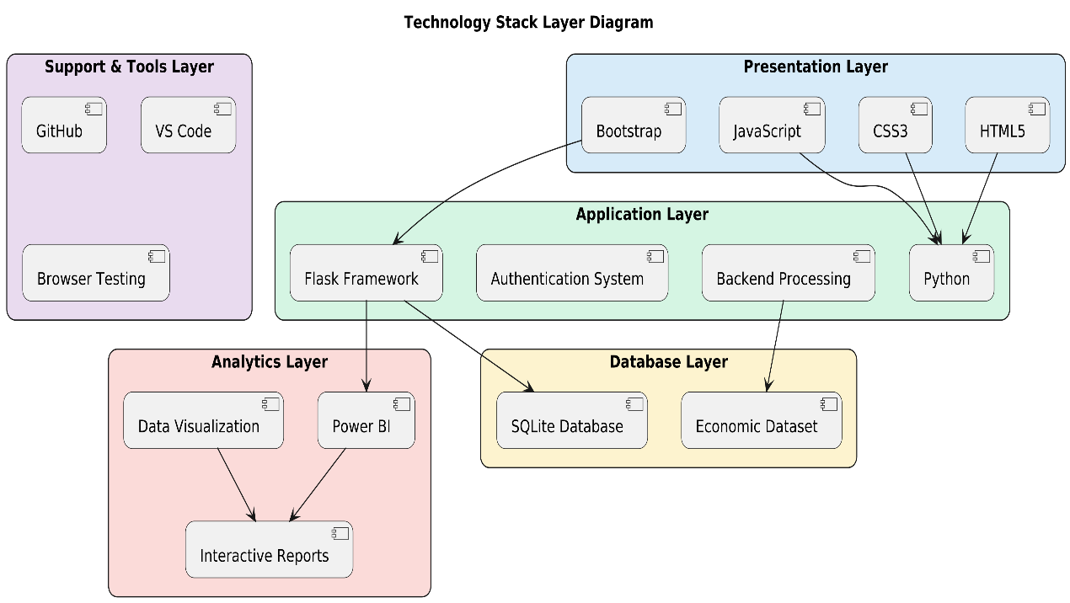
Fig 2.4: Technology Stack Layer Diagram
Above Fig 2.4 shows the technology stack layer diagram of the GIDA platform, illustrating the different technologies used in the presentation layer, application layer, analytics layer, database layer, and support tools for developing and managing the system.
2.6.1 HTML
HTML (HyperText Markup Language) is used to create the basic structure and layout of the web application. It helps design different sections of the website such as navigation bars, dashboard containers, forms, buttons, menus, and content areas. HTML provides the foundation for displaying analytical information and organizing frontend components within the application. In this project, HTML is used to create a structured and user-friendly interface that allows users to access dashboards and analytics features easily.
2.6.2 CSS
CSS (Cascading Style Sheets) is used for styling and improving the visual appearance of the website. It helps control the colors, fonts, spacing, layouts, alignment, responsiveness, and overall design of the user interface. CSS makes the application visually attractive and ensures that the web pages maintain a professional and organized appearance across different devices and screen sizes. Responsive design techniques are implemented using CSS so that users can interact with the analytics platform smoothly and comfortably.
2.6.3 JavaScript
JavaScript is used to provide dynamic functionality and interactivity within the frontend system. It allows the web application to respond to user actions such as selecting filters, navigating pages, interacting with dashboards, and updating visual components dynamically. JavaScript improves user experience by enabling smooth transitions, real-time updates, and responsive interactions within the application. In this project, JavaScript helps manage frontend behavior and supports communication between user interface elements and backend functionalities.
2.6.4 Python
Python is used as the main backend programming language of the project. It handles backend processing, analytical workflows, dataset management, preprocessing operations, and communication between the frontend, database, and visualization layers. Python is selected because of its simplicity, flexibility, and strong support for data analytics and web application development. The backend system uses Python to process economic datasets, perform cleaning and transformation operations, manage database connectivity, and support dashboard integration within the application.
2.6.5 SQLite
SQLite is used as the database management system for storing and organizing project-related data. It provides a lightweight and efficient environment for managing datasets, processed records, and analytical information within the platform. SQLite allows the backend system to perform operations such as data insertion, retrieval, updating, and query execution efficiently. The use of SQLite simplifies database management while maintaining good performance and structured data handling for analytical operations.
2.6.6 Power BI
Power BI is used for creating interactive dashboards and business intelligence visualizations within the project. It helps convert large and complex economic datasets into understandable charts, graphs, reports, and analytical dashboards. Power BI provides interactive features such as filters, slicers, comparative analysis, and dynamic reporting that improve user understanding of global income distribution and economic inequality. The dashboards created using Power BI are integrated into the web application to provide users with advanced analytical visualization features.
2.6.7 Pandas
Pandas is a Python library used for data manipulation and preprocessing operations. It helps in reading datasets, cleaning data, handling missing values, formatting records, performing transformations, and organizing information into structured formats. Pandas plays an important role in preparing economic datasets before visualization and analytical processing. The library improves data consistency and simplifies operations related to data analysis and management.
2.6.8 NumPy
NumPy is a Python library used for numerical and mathematical operations within the system. It supports array processing, statistical calculations, normalization, and numerical analysis of datasets. NumPy helps improve the efficiency of backend data processing operations and supports analytical calculations required during preprocessing and visualization workflows.
2.6.9 Full-Stack Integration
The project combines frontend technologies, backend processing, database management, and business intelligence visualization into a single integrated system. HTML, CSS, and JavaScript manage the frontend interface, Python handles backend processing, SQLite manages the database, while Power BI provides analytical dashboards and visualization capabilities. Libraries such as Pandas and NumPy support data preprocessing and transformation. Together, these technologies create a complete full-stack analytics platform capable of analyzing and visualizing global income distribution data interactively and efficiently.

Chapter 3
Features & Functionality
The “Interactive Analytics Dashboard for Global Income Distribution” project includes several features and functionalities that help users analyze, visualize, and understand global economic and income distribution data more effectively. The system is designed as a full-stack analytics web application that combines frontend interaction, backend processing, database management, and business intelligence visualization within a single platform. The main objective of the system is to simplify complex economic analysis through interactive dashboards, graphical reports, and user-friendly analytical tools.
One of the major features of the system is the interactive analytics dashboard integrated using Power BI. The dashboard helps transform large and complex economic datasets into visual insights through charts, graphs, reports, and comparative analytics. Users can interact with the dashboard dynamically and analyze information related to GDP per capita, Gini Index, poverty ratio, income distribution, and regional economic trends. The use of interactive visualization makes economic analysis easier and more understandable compared to traditional spreadsheets and static reports.
The system also provides country-wise and region-wise comparative analysis features. Users can compare economic conditions between different countries and regions using graphical visualizations and filtering options. This functionality helps users identify patterns related to economic inequality, financial growth, and wealth distribution across various parts of the world. Comparative analytics improves the understanding of global economic differences and supports better analytical interpretation.
Another important functionality of the project is dynamic filtering and user interaction. The dashboard allows users to apply filters based on countries, regions, years, and economic indicators. Once filters are selected, the visualizations update dynamically and display customized analytical results according to user requirements. This interactive behavior improves flexibility and allows users to perform detailed analysis more efficiently.
The frontend functionality of the application is developed using HTML, CSS, and JavaScript. The frontend provides a responsive and user-friendly interface that allows users to navigate through different sections of the website smoothly. Features such as navigation menus, dashboard sections, analytical reports, and visualization panels are organized in a structured manner to improve usability and accessibility of the platform.
Backend functionalities are implemented using Python, which handles important operations such as data preprocessing, analytical workflows, database communication, and dashboard integration. The backend system manages data processing efficiently and supports smooth communication between the frontend interface, database layer, and Power BI visualization modules. Python libraries such as Pandas and NumPy are used for data cleaning, formatting, transformation, and preprocessing operations before visualization.
The system also includes database management functionality using SQLite. The database stores economic datasets, processed information, and analytical records in an organized format. SQLite helps manage data retrieval, updating, and storage operations efficiently, ensuring smooth analytical processing and proper management of datasets within the platform.
Another significant feature of the project is data visualization and graphical analytics. Different types of charts and visual reports such as bar graphs, pie charts, line charts, comparative graphs, and trend visualizations are used within the dashboard to represent economic information clearly. These visualization techniques help users understand trends, compare data, and identify relationships between different economic indicators more effectively.
The project additionally focuses on responsive design and improved user experience. The application interface is designed to work smoothly across different screen sizes and devices, making the system more accessible and convenient for users. Interactive controls, responsive layouts, and simplified navigation improve overall usability and make the analytics platform easier to operate.
The system architecture is also designed to support scalability and future enhancements. Additional functionalities such as real-time data integration, Artificial Intelligence-based analytics, predictive modeling, cloud database connectivity, and advanced reporting systems can be integrated into the platform in future versions without major modifications to the existing architecture.
Overall, the features and functionalities of the “Interactive Analytics Dashboard for Global Income Distribution” project provide an effective and user-friendly environment for analyzing global economic data through interactive dashboards, full-stack web technologies, backend processing, database management, and business intelligence visualization tools.
3.1 Introduction to Features
The “Interactive Analytics Dashboard for Global Income Distribution” project is developed with several important features and functionalities that help users analyze and visualize global economic data in a simple, interactive, and efficient manner. The system is designed as a full-stack web application that combines frontend technologies, backend processing, database management, and business intelligence visualization into a single integrated platform. The features of the system focus on improving user interaction, simplifying complex data analysis, and providing meaningful insights related to global income distribution and economic inequality.
One of the main goals of the project is to transform large and complex economic datasets into understandable visual reports using interactive dashboards and analytical tools. Instead of relying on traditional spreadsheets or static reports, the system provides graphical visualizations, dynamic charts, and comparative analytics that make economic information easier to interpret. Users can interact with the platform through filters, dashboard controls, and visualization components to perform customized analysis according to their requirements.
The project includes features related to data preprocessing, dashboard visualization, country-wise analysis, region-wise comparison, backend data handling, and database management. These functionalities work together to provide a smooth analytical workflow within the application. The frontend interface is designed to improve usability and accessibility, while backend processing ensures efficient handling of datasets and analytical operations.
Another important aspect of the system is its ability to provide interactive business intelligence visualization using Power BI integration. The dashboards allow users to study trends, compare economic indicators, analyze inequality patterns, and observe financial distributions through visual reports and interactive charts. This improves understanding of global economic conditions and helps users generate meaningful insights more effectively.
The features and functionalities of the system are designed not only to improve analytical capabilities but also to provide better user experience and system flexibility. The platform supports responsive interaction, dynamic updates, structured data management, and future scalability for integrating advanced analytical technologies and additional functionalities. Overall, the project provides a modern analytics environment that combines full-stack web technologies with business intelligence visualization to simplify the analysis of global income distribution data.
3.2 User Authentication System
The User Authentication System is one of the important features of the “Interactive Analytics Dashboard for Global Income Distribution” project. This functionality helps provide secure access to the web application and ensures that only authorized users can use the analytics platform and its features. The authentication system improves security, protects user-related information, and helps manage access to different sections of the website in a structured manner.
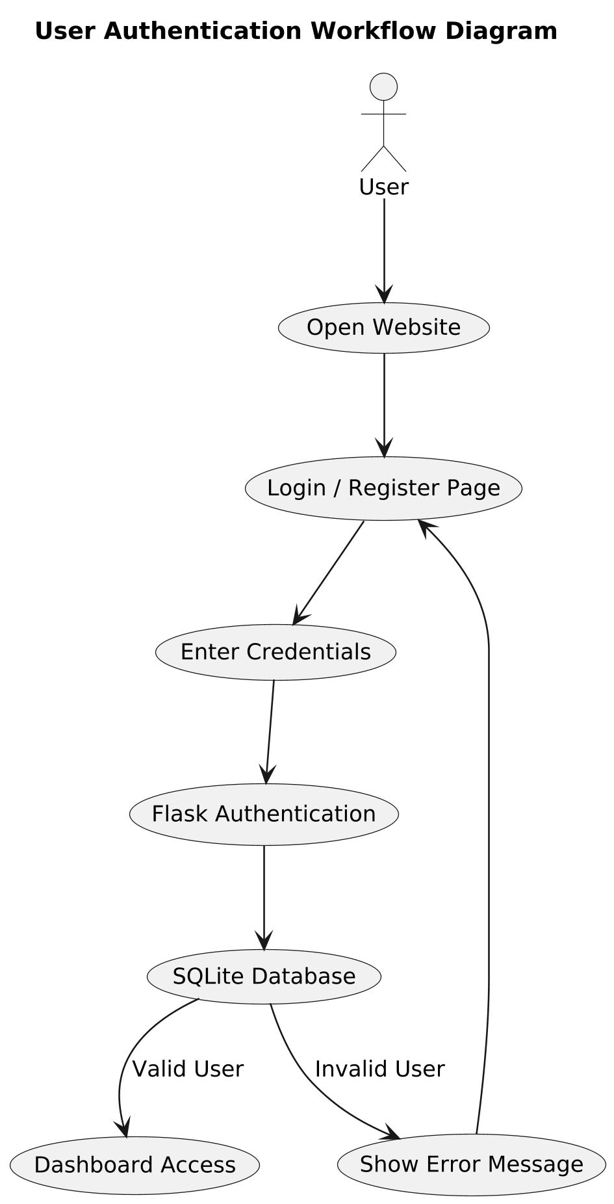
Fig 3.1: User Authentication Workflow Diagram
Above Fig 3.1 shows the user authentication workflow of the GIDA platform, where the user accesses the website, enters login credentials, and the Flask authentication system verifies the details using the SQLite database before providing dashboard access or displaying an error message. The authentication process mainly includes user registration, login validation, and session management functionalities. New users can create their accounts by providing necessary details such as username, email address, and password through the registration interface. The system verifies the entered information and stores the user credentials securely within the SQLite database for future login operations.
The login functionality allows registered users to access the system using their valid username or email and password. When users enter their login credentials, the backend system developed using Python verifies the information stored in the database. If the entered details match the stored records, the user is successfully authenticated and allowed to access the analytics dashboard and application features. If invalid credentials are entered, the system displays appropriate error messages and restricts unauthorized access.
The authentication system also supports session management, which helps maintain user login status while interacting with the website. Once users successfully log in, the system keeps track of their active session and allows smooth navigation between different pages and dashboard modules without repeated login requests. Proper session handling improves user experience and application security.
Frontend technologies such as HTML, CSS, and JavaScript are used to design the login and registration interfaces in a responsive and user-friendly manner. These interfaces provide forms, validation messages, and interactive controls that help users perform authentication operations easily. The backend processing implemented using Python handles authentication logic, password verification, database communication, and user validation processes efficiently.
SQLite is used to manage user-related information and authentication records within the system. User credentials and login details are stored in structured database tables, which support efficient retrieval and validation during login operations. Database management also helps maintain proper organization and security of user information.
The User Authentication System improves the reliability and security of the analytics platform by preventing unauthorized access and ensuring that only authenticated users can interact with the dashboard and analytical features. It also provides a foundation for implementing future enhancements such as role-based access control, password encryption, user profile management, and advanced security mechanisms within the web application.
3.3 Interactive Dashboard Feature
The Interactive Dashboard Feature is one of the core functionalities of the “Interactive Analytics Dashboard for Global Income Distribution” project. This feature is designed to help users analyze global economic and income distribution data through interactive visualizations, graphical reports, and dynamic analytical tools. Instead of viewing static tables or spreadsheets, users can explore economic information more effectively using charts, filters, comparative analytics, and real-time visual updates provided within the dashboard environment.
The dashboard is developed using Power BI and integrated into the web application to provide advanced business intelligence and visualization capabilities. It converts large and complex economic datasets into understandable graphical insights, making it easier for users to study income inequality, GDP growth, poverty ratios, and regional economic patterns. Interactive visualizations improve analytical understanding by representing data in a visually organized and meaningful format.
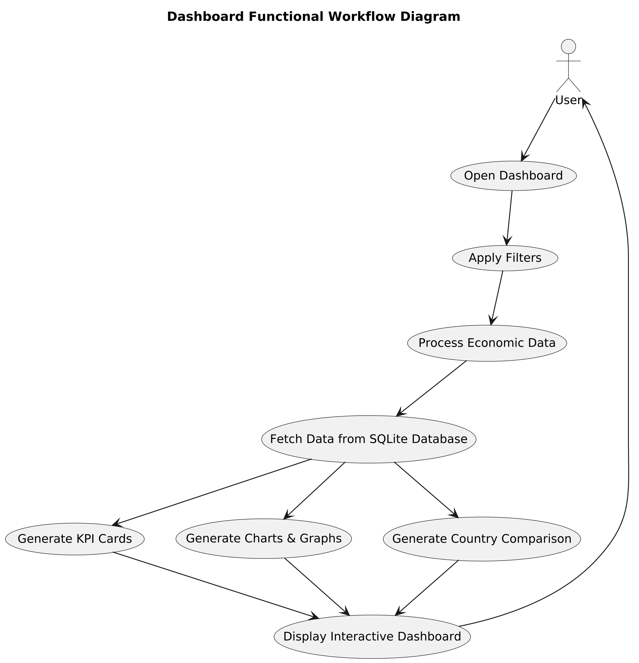
Fig 3.2: Dashboard Functional Workflow Diagram
Above Figure 3.2 illustrates the functional workflow of the GIDA dashboard system. The process starts when the user opens the dashboard and applies filters. The system then processes the economic data from the SQLite database and generates KPI cards, charts, graphs, and country comparison insights in an interactive dashboard format. One of the major advantages of the interactive dashboard is dynamic user interaction. Users can apply filters based on countries, regions, years, and economic indicators to generate customized analytical results. When filters are selected, the dashboard automatically updates charts, graphs, and reports according to the selected criteria. This allows users to perform detailed comparative analysis and study specific economic trends more efficiently.
The dashboard includes different visualization components such as bar charts, pie charts, line graphs, comparative reports, and trend analysis charts. These visualizations help users identify patterns, compare financial conditions between countries, and observe changes in income distribution over different periods. The graphical representation of data simplifies complex economic information and improves the readability of analytical reports.
Another important feature of the dashboard is country-wise and region-wise comparative analytics. Users can compare multiple countries or regions simultaneously and analyze economic differences using interactive charts and visual reports. This functionality helps researchers, students, and analysts understand global economic inequality and identify areas with varying financial conditions more effectively.
The interactive dashboard is integrated with the frontend interface developed using HTML, CSS, and JavaScript. The frontend provides a responsive and user-friendly environment where users can access analytical reports smoothly and interact with visualization controls easily. Backend processing implemented using Python supports dashboard integration and ensures proper handling of processed datasets before visualization.
The dashboard feature also improves accessibility and user experience by allowing users to analyze economic information without requiring advanced technical knowledge. The visual and interactive nature of the dashboard makes data analysis easier for both technical and non-technical users. Instead of manually studying raw datasets, users can quickly generate insights through graphical analytics and dynamic filtering mechanisms.
Overall, the Interactive Dashboard Feature provides a modern and efficient way of analyzing global income distribution and economic inequality through business intelligence visualization and full-stack web integration. It enhances analytical understanding, improves user interaction, and simplifies complex economic analysis through interactive charts, dashboards, and comparative reporting tools.
3.4 Dynamic Filtering and Search
The Dynamic Filtering and Search feature is one of the important functionalities of the“Interactive Analytics Dashboard for Global Income Distribution” project. This feature helps users analyze economic data more efficiently by allowing them to filter and search information according to their specific requirements. Instead of viewing all datasets together, users can customize the analysis and focus only on the information they want to study. This makes the dashboard more interactive, flexible, and user-friendly.
The filtering system allows users to apply different types of filters such as country-wise filters, region-wise filters, year selection filters, and economic indicator filters. By selecting specific options, users can narrow down large datasets and generate customized visual reports. For example, users can compare the income distribution of selected countries, study regional economic trends, or analyze economic indicators for a particular time period. Once a filter is applied, the dashboard automatically updates charts, graphs, and analytical reports according to the selected values.
The search functionality further improves user interaction by allowing users to quickly find specific countries, regions, or economic information within the platform. Instead of manually browsing through large datasets, users can search directly for required data using search fields and filtering controls. This saves time and improves the efficiency of data analysis and navigation within the system.
The dynamic behavior of the filtering system is supported using frontend technologies such as JavaScript along with Power BI interactive controls. JavaScript helps manage user interaction and dynamically update frontend components, while Power BI provides advanced filtering and slicer functionalities for dashboard analytics. The backend system implemented using Python ensures proper handling and processing of filtered data before it is displayed to users.
Dynamic filtering and search features improve the flexibility and usability of the analytics platform by allowing users to perform customized comparative analysis easily. Users can study specific economic conditions, compare financial indicators, and identify trends more effectively without dealing with unnecessary or unrelated information. This makes the platform more suitable for researchers, students, analysts, and users who want detailed insights into global income distribution and economic inequality.
3.5 Visualization Features
Visualization is one of the most important parts of the “Interactive Analytics Dashboard for Global Income Distribution” project because it helps convert large and complex economic datasets into understandable graphical insights. Instead of presenting data only in numerical tables or spreadsheets, the system uses different types of visualizations such as charts, graphs, and analytical dashboards to make economic analysis easier and more interactive for users. These visualization features improve understanding of global income distribution, economic inequality, GDP growth, poverty ratios, and regional financial patterns through clear and meaningful graphical representation.
The project integrates Power BI dashboards to provide advanced business intelligence visualization capabilities within the web application. Different visualization components are used to represent economic data in multiple formats so that users can study trends, comparisons, and analytical patterns more effectively. Interactive visualizations also allow users to explore data dynamically using filters and analytical controls.
One of the major visualization features used in the system is bar charts. Bar charts help compare economic indicators such as GDP per capita, income distribution, and poverty levels across different countries or regions. They provide a simple and effective way to understand differences between multiple datasets and identify regions with varying economic conditions.
The system also uses line graphs for trend analysis and time-based visualization. Line charts help users observe changes in economic indicators over different years and identify long-term financial patterns or growth trends. These visualizations are useful for studying economic development and understanding how income distribution changes over time.
Pie charts are another important visualization feature included in the dashboard. Pie charts help represent percentage-based distribution of economic indicators and provide an easy understanding of proportional data. They are useful for displaying income share, population-based economic distribution, and regional contribution to overall financial conditions.
Comparative charts and analytical graphs are also integrated into the dashboard for country-wise and region-wise comparison. These visualizations allow users to compare multiple countries or economic regions simultaneously and analyze differences in financial growth, inequality, and development levels. Comparative analytics improves the ability to identify economic patterns and perform detailed analysis more effectively.
The dashboard additionally supports interactive filtering and dynamic visualization updates. Users can apply filters based on countries, regions, years, and economic indicators, and the charts automatically update according to the selected data. This interactive behavior improves user experience and allows customized analytical exploration within the platform.
Frontend technologies such as HTML, CSS, and JavaScript help display the visualization components properly within the web interface, while backend processing using Python ensures that cleaned and processed datasets are supplied to the visualization layer accurately. Power BI integration further enhances the quality and interactivity of the visual reports and dashboards.
Another important advantage of the visualization features is improved readability and simplified interpretation of economic data. Users do not need advanced technical knowledge to understand the analytical results because graphical representations make complex datasets easier to study and analyze. Visual analytics also reduces manual effort and improves decision-making by presenting information in a more organized and understandable format.
Overall, the visualization features of the project provide an effective way to analyze global economic data through interactive dashboards, graphical reports, comparative analytics, and dynamic charts. These features improve analytical understanding, user interaction, and accessibility of the platform while supporting efficient study of global income distribution and economic inequality.
3.6 Advantages of Functionalities
The functionalities of the “Interactive Analytics Dashboard for Global Income Distribution” project provide several advantages that improve data analysis and user experience. The system helps users understand complex economic data more easily through interactive dashboards, graphical visualizations, and dynamic analytical features. Instead of depending on traditional spreadsheets and static reports, users can explore data in a more simple and efficient manner.
One major advantage of the system is interactive visualization, which allows users to analyze income distribution and economic trends through charts, graphs, and comparative reports. Dynamic filtering and search functionalities help users customize analysis according to countries, regions, years, and economic indicators, making the platform more flexible and user-friendly.
The project also improves analytical accuracy through proper data preprocessing and organized database management. Backend processing using Python and SQLite ensures smooth handling of datasets and efficient system performance. The responsive frontend interface developed using HTML, CSS, and JavaScript further improves accessibility and navigation within the application.
Another important advantage is the integration of Power BI dashboards, which provides advanced business intelligence and interactive reporting capabilities. Users can study regional economic patterns, compare financial conditions, and identify long-term trends more effectively through visual analytics.
Overall, the functionalities of the system simplify global economic analysis, improve user interaction, and provide a modern platform for understanding income inequality and financial distribution through full-stack web technologies and interactive visualization tools.

Chapter 4
System Workflow and Processing
The system workflow and processing of the “Interactive Analytics Dashboard for Global Income Distribution” project describe how data moves through different stages of the application, from data collection to visualization and user interaction. The workflow is designed to ensure smooth processing, accurate analysis, and efficient visualization of global economic data within the platform.
The workflow begins with collecting economic datasets from reliable sources such as the World Bank, IMF, and OECD. These datasets contain information related to GDP per capita, income distribution, poverty ratio, Gini Index, and other financial indicators. After collection, the data is processed and cleaned using Python libraries such as Pandas and NumPy to remove missing values, duplicate records, and formatting inconsistencies.
Once preprocessing is completed, the organized data is stored in the SQLite database, which helps manage datasets and analytical records efficiently. The backend system developed using Python retrieves the required information from the database and processes it for dashboard generation and visualization.
The processed data is then integrated with Power BI dashboards to create interactive charts, graphs, and analytical reports. These dashboards are displayed within the web application developed using HTML, CSS, and JavaScript. Users can interact with the system through filters, search options, and visualization controls to perform customized analysis and study global income distribution patterns more effectively.
The workflow also includes dynamic interaction between frontend components, backend processing, database management, and visualization modules to ensure smooth system performance and real-time analytical updates. Overall, the workflow and processing architecture help provide an efficient, user-friendly, and interactive environment for analyzing global economic data through full-stack web technologies and business intelligence visualization tools.
4.1 Overall Workflow Introduction
The overall workflow of the “Interactive Analytics Dashboard for Global Income Distribution” project is designed to ensure smooth processing, management, and visualization of global economic data within the system. The workflow explains how data moves through different stages of the application, starting from data collection and preprocessing to dashboard visualization and user interaction. Each component of the system works together to provide accurate analysis and interactive analytical insights.
The workflow begins with collecting economic datasets from reliable sources such as the World Bank, IMF, and OECD. These datasets contain important information related to income distribution, GDP per capita, poverty ratio, Gini Index, and regional economic indicators. After collecting the data, preprocessing operations are performed using Python libraries such as Pandas and NumPy to clean and organize the datasets. Missing values, duplicate records, and formatting issues are removed to improve data quality and consistency.
Once the data is processed, it is stored in the SQLite database, where datasets and analytical records are managed efficiently. The backend system developed using Python retrieves the required information from the database and performs analytical processing according to user requests and dashboard requirements.
The processed data is then integrated with Power BI dashboards to generate interactive visualizations such as charts, graphs, and analytical reports. These dashboards are displayed through the frontend interface developed using HTML, CSS, and JavaScript. Users can interact with the platform using filters, search options, and dashboard controls to perform customized analysis and study global income distribution patterns more effectively.
Overall, the workflow of the system provides a structured and efficient process for handling economic datasets, generating visual analytics, and delivering interactive insights through a full-stack web-based analytics platform.
4.2 Data Collection Workflow
The Data Collection Workflow of the “Interactive Analytics Dashboard for Global Income Distribution” project focuses on gathering economic and financial datasets from reliable and publicly available sources. This workflow is important because the accuracy and quality of the analytical results depend on the correctness and consistency of the collected data. The system is designed to collect and organize data in a structured manner before further processing and visualization.
The workflow begins with identifying trusted data sources such as the World Bank, IMF, OECD, and other global economic databases. These sources provide important information related to GDP per capita, Gini Index, poverty ratio, income distribution, population statistics, and regional economic indicators. The collected datasets help analyze economic inequality and financial conditions across different countries and regions.
After selecting the data sources, the required datasets are downloaded and organized according to analytical requirements. Since the data is collected from multiple sources, the datasets may contain different formats, structures, and naming conventions. Therefore, proper organization of files and records is performed before preprocessing operations begin.
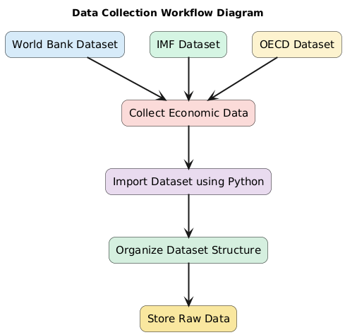
Fig 4.1: Data Collection Workflow Diagram
Above Figure 4.1 illustrates the data collection workflow of the GIDA system. Economic datasets are collected from multiple sources such as the World Bank, IMF, and OECD. The collected data is then imported using Python, organized into a structured format, and finally stored as raw data for further processing and analytics. The collected data is then imported into the backend processing environment using Python. Libraries such as Pandas are used to read and manage datasets efficiently. During this stage, the system checks for missing values, duplicate records, inconsistent formatting, and incomplete information. These issues are identified for further preprocessing and cleaning operations.
The workflow also includes classification and grouping of data based on countries, regions, years, and economic indicators. This organized structure helps simplify analytical processing and improves the efficiency of visualization and comparative analysis within the dashboard system.
Once the datasets are properly collected and organized, they are passed to the preprocessing stage, where cleaning, transformation, and normalization operations are performed before storing the processed information in the SQLite database. Overall, the data collection workflow provides a structured process for gathering reliable economic data and preparing it for interactive analytics and visualization within the platform.
4.3 Data Preprocessing Workflow
The Data Preprocessing Workflow is an important stage in the “Interactive Analytics Dashboard for Global Income Distribution” project because raw economic datasets often contain missing values, duplicate records, inconsistent formats, and unnecessary information. Proper preprocessing is necessary to improve data quality, accuracy, and consistency before performing analytical operations and visualization. This workflow helps prepare the collected datasets for efficient processing and dashboard integration.
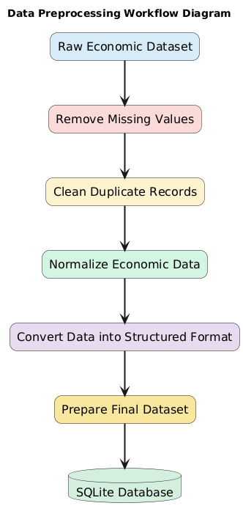
Fig 4.2: Data Preprocessing Diagram
Above Figure 4.2 illustrates the data preprocessing workflow of the GIDA system. The raw economic dataset is cleaned by removing missing values and duplicate records. The data is then normalized, converted into a structured format, and prepared as the final dataset before being stored in the SQLite database for analytics and visualization. The preprocessing workflow begins after the economic datasets are collected from sources such as the World Bank, IMF, and OECD. The datasets are first imported into the backend processing environment using Python. Libraries such as Pandas and NumPy are used to read, organize, and manage the data efficiently.
The first step in preprocessing is data cleaning. During this stage, missing values, incomplete records, and duplicate entries are identified and handled properly. Records with invalid or inconsistent information are corrected or removed to improve the reliability of the datasets. This step helps ensure that the analytical results generated by the system are accurate and meaningful.
After cleaning, the workflow performs data transformation and formatting operations. Since datasets collected from multiple sources may have different structures and naming formats, the data is standardized into a common and organized format. Country names, economic indicators, numerical values, and date formats are adjusted for consistency across all records.
The preprocessing workflow also includes normalization and organization of data for analytical purposes. Economic indicators are grouped according to countries, regions, and years so that comparative analysis and visualization become easier within the dashboard system. Unnecessary columns and irrelevant information are removed to improve processing efficiency and reduce data complexity.
Once preprocessing is completed, the cleaned and transformed datasets are stored in the SQLite database for further backend processing and visualization. The processed data is then integrated with Power BI dashboards to generate interactive charts, graphs, and analytical reports.
Overall, the Data Preprocessing Workflow helps improve the quality, consistency, and usability of the economic datasets used within the project. It ensures that the system provides accurate visual insights and reliable analytical results for studying global income distribution and economic inequality.

4.4 Database Processing Workflow
The Database Processing Workflow of the “Interactive Analytics Dashboard for Global Income Distribution” project is designed to manage the storage, retrieval, and processing of economic datasets within the system. This workflow helps organize large amounts of data in a structured manner and ensures smooth communication between the backend system, database layer, and visualization modules. Efficient database processing is important for maintaining data consistency, improving system performance, and supporting analytical operations within the platform.
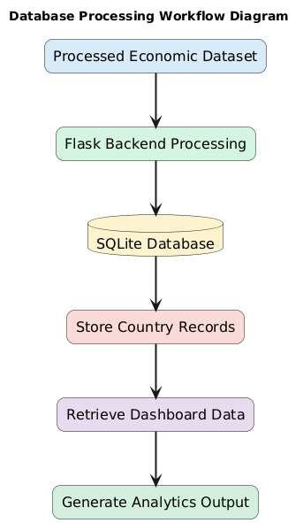
Fig 4.3: Database Preprocessing Diagram
Above Figure 4.3 illustrates the database processing workflow of the GIDA system. The processed economic dataset is handled through the Flask backend and stored in the SQLite database. The system then retrieves the required dashboard data and generates analytical outputs for visualization and reporting. The workflow begins after the preprocessing stage, where cleaned and organized datasets are prepared for storage. The processed economic data is stored in the SQLite database, which acts as the central storage system of the application. SQLite is used because it is lightweight, efficient, and easy to integrate with Python backend processing. The database stores information related to countries, regions, GDP per capita, income distribution, poverty ratio, Gini Index, and other economic indicators in structured tables.
Once the data is stored, the backend system developed using Python communicates with the database to perform various operations such as data insertion, retrieval, updating, and query execution. SQL queries are used to access the required information from the database whenever users request specific analytics or dashboard visualizations. This helps the system retrieve data quickly and efficiently for analytical processing.
The database workflow also supports filtering and comparative analysis operations. When users apply filters such as country selection, region selection, or year filtering within the dashboard, the backend retrieves only the required records from the database. This improves system efficiency and ensures faster dashboard updates and analytical responses.
Another important part of the database processing workflow is maintaining data organization and consistency. Economic datasets collected from different sources are stored in a structured format to reduce redundancy and simplify analytical operations. Proper database organization helps improve the reliability of the visual reports and dashboards generated within the system.
The processed information retrieved from the database is then passed to the Power BI visualization layer, where interactive charts, graphs, and analytical dashboards are generated. The frontend interface displays these visual reports and allows users to interact with the analytics system dynamically.
Overall, the Database Processing Workflow provides a structured and efficient process for storing, managing, retrieving, and processing global economic data within the analytics platform. It ensures smooth backend operations, accurate analytical processing, and reliable dashboard visualization throughout the system.
4.5 Backend Processing Workflow
The Backend Processing Workflow of the “Interactive Analytics Dashboard for Global Income Distribution” project is responsible for managing the core operations and analytical processing of the system. The backend acts as the central processing layer that handles communication between the frontend interface, database system, and visualization modules. It ensures that data is processed correctly and analytical operations are performed efficiently within the platform.
The backend workflow begins after the economic datasets are collected and preprocessed. The cleaned and organized data stored in the SQLite database is accessed through the Python backend system. Python is used because it provides strong support for data processing, backend development, and analytical operations. The backend retrieves the required datasets from the database whenever users request specific analytics or dashboard reports.
One of the main tasks of the backend workflow is handling data processing and analytical operations. The backend manages calculations, filtering operations, data organization, and communication between different components of the system. When users apply filters such as country selection, region selection, or year selection, the backend processes the request and retrieves the corresponding information from the database.
The backend workflow also supports communication with the Power BI visualization layer. After processing the required data, the backend supplies the information needed for generating interactive charts, graphs, and analytical dashboards. This ensures that users receive accurate and updated visual insights according to their selected analytical parameters.
Another important function of the backend workflow is managing user requests and maintaining smooth interaction between frontend and database components. The backend receives requests from the web interface, processes them using Python logic, and returns the appropriate analytical results or dashboard responses. This process helps maintain proper synchronization between the user interface and system operations.
Error handling and system validation are also included in the backend workflow. The backend checks for invalid inputs, database connection issues, and processing errors to ensure stable system performance and reliable analytical results. Proper error handling improves system reliability and enhances user experience during interaction with the platform.
Overall, the Backend Processing Workflow provides an organized and efficient process for handling analytical operations, database communication, dashboard integration, and user requests within the system. It plays an important role in ensuring smooth functionality of the full-stack analytics platform and supports accurate visualization of global income distribution data.

4.6 Frontend Workflow
The Frontend Workflow of the “Interactive Analytics Dashboard for Global Income Distribution” project is designed to manage user interaction and display analytical information through a responsive and user-friendly web interface. The frontend acts as the visible part of the system where users interact with the application, access dashboards, apply filters, and analyze economic data using graphical visualizations and interactive controls.
The workflow begins when the user opens the web application through the browser. The frontend interface developed using HTML, CSS, and JavaScript loads the homepage, navigation menus, dashboard sections, and analytical components of the system. HTML is used to structure the web pages, CSS improves the visual appearance and responsiveness of the interface, while JavaScript provides dynamic interaction and frontend functionality.
After accessing the platform, users can navigate through different sections of the application such as dashboards, analytical reports, and visualization panels. The frontend workflow allows users to interact with filters, search options, and dashboard controls to customize the analysis according to their requirements. Users can select countries, regions, years, or economic indicators for generating specific analytical insights.
When a user performs any action such as applying filters or requesting analytics, the frontend sends the request to the backend processing system. The backend retrieves the required information from the SQLite database and returns the processed data to the frontend interface. The frontend then updates the dashboard visualizations dynamically and displays the analytical results through charts, graphs, and comparative reports.
The frontend workflow also supports integration of Power BI dashboards within the website. Interactive dashboards and visualization components are displayed directly on the web pages, allowing users to analyze economic trends and income distribution data more effectively. The interface updates visualizations in real time based on user interaction and filtering operations.
Another important aspect of the frontend workflow is responsive design and smooth user experience. The frontend is designed to work properly across different devices and screen sizes, ensuring accessibility and ease of use for users. Navigation components, dashboard sections, and analytical controls are organized systematically to improve usability and interaction within the platform.
Overall, the Frontend Workflow provides a structured process for handling user interaction, dashboard display, dynamic filtering, and visualization updates within the analytics platform. It plays an important role in improving accessibility, responsiveness, and user experience while supporting efficient analysis of global income distribution data.
4.7 Dashboard Processing Workflow
The Dashboard Processing Workflow of the “Interactive Analytics Dashboard for Global Income Distribution” project is responsible for generating, updating, and displaying interactive analytical dashboards within the web application. This workflow helps transform processed economic datasets into meaningful visual insights through charts, graphs, reports, and comparative analytics. The main objective of the dashboard workflow is to provide users with an interactive and user-friendly environment for analyzing global income distribution and economic inequality.
The workflow begins after the economic datasets are collected, cleaned, and stored in the SQLite database. The backend system developed using Python retrieves the processed data from the database according to user requirements and analytical operations. The required datasets are then prepared for visualization and integrated with Power BI dashboards.
Power BI is used to create interactive business intelligence dashboards that visually represent economic indicators such as GDP per capita, Gini Index, poverty ratio, income distribution, and regional financial trends. Different visualization components such as bar charts, line graphs, pie charts, comparative reports, and trend analysis graphs are generated within the dashboard environment to improve understanding of complex economic data.
The dashboard processing workflow also supports dynamic interaction and real-time analytical updates. When users apply filters such as country selection, region selection, or year filtering, the backend processes the request and updates the dashboard accordingly. The visualizations automatically refresh and display customized analytical insights based on the selected parameters. This dynamic behavior improves flexibility and allows users to perform detailed comparative analysis more effectively.
The frontend interface developed using HTML, CSS, and JavaScript displays the Power BI dashboards within the website. Users can interact with the dashboard using filters, visualization controls, and analytical options provided through the interface. The integration between frontend components, backend processing, and Power BI visualization ensures smooth communication and efficient dashboard performance within the platform.
Another important part of the dashboard workflow is maintaining visualization accuracy and consistency. Since the data used for dashboards is preprocessed and organized before visualization, the generated analytical reports remain reliable and meaningful. The workflow also helps improve system responsiveness by retrieving only the required data for dashboard generation instead of processing unnecessary information.
Overall, the Dashboard Processing Workflow provides a structured and efficient process for generating interactive dashboards, handling analytical visualization, and supporting dynamic user interaction within the platform. It plays an important role in simplifying global economic analysis through business intelligence visualization and full-stack web integration.
4.8 User Interaction Workflow
The User Interaction Workflow of the “Interactive Analytics Dashboard for Global Income Distribution” project explains how users interact with the web application to access dashboards, apply filters, analyze economic data, and generate visual insights. The workflow is designed to provide a smooth, responsive, and user-friendly experience that allows users to perform analytical operations easily without requiring advanced technical knowledge.
The workflow begins when the user opens the web application through the browser. The homepage and dashboard interface developed using HTML, CSS, and JavaScript are loaded, providing users with access to navigation menus, analytical sections, and visualization components. The responsive frontend interface helps users move smoothly between different sections of the platform.
After accessing the dashboard, users can interact with different analytical features such as filters, search options, charts, and comparative reports. Users can select specific countries, regions, years, or economic indicators according to their analytical requirements. These selections help customize the dashboard and generate focused analytical results instead of displaying all data together.
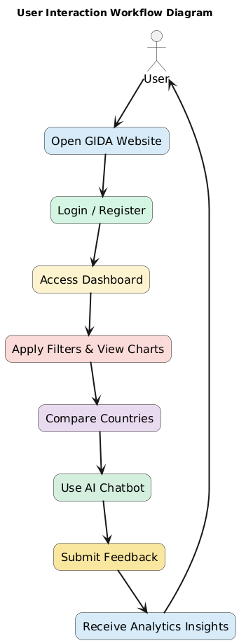
Fig 4.4: User Interaction Diagram
Above Figure 4.4 illustrates the user interaction workflow of the GIDA system. The process begins when the user opens the website and logs into the platform. After accessing the dashboard, the user can apply filters, compare countries, interact with the AI chatbot, and submit feedback. Finally, the system provides analytical insights and interactive economic visualizations to the user.
Once a user applies filters or requests specific analysis, the frontend sends the request to the backend processing system. The backend developed using Python retrieves the required data from the SQLite database and processes it according to the selected parameters. The processed information is then sent to the Power BI dashboard layer for visualization.
The dashboard updates dynamically and displays interactive charts, graphs, and analytical reports based on user selections. Users can continue interacting with the dashboard by changing filters, comparing countries, studying trends, or exploring different economic indicators. This dynamic interaction improves analytical flexibility and allows users to generate customized insights efficiently.
The workflow also focuses on improving usability and accessibility. The interface is designed to be simple and easy to understand so that both technical and non-technical users can interact with the system comfortably. Smooth navigation, responsive controls, and real-time dashboard updates help improve overall user experience within the analytics platform.
Overall, the User Interaction Workflow provides a structured process that connects user actions with backend processing, database operations, and dashboard visualization. It ensures smooth communication between different components of the system and supports efficient analysis of global income distribution through interactive web technologies and business intelligence dashboards.
4.9 Testing and Validation Workflow
The Testing and Validation Workflow of the “Interactive Analytics Dashboard for Global Income Distribution” project is designed to ensure that the system works properly, generates accurate analytical results, and provides a smooth user experience. Testing is an important stage in the development process because it helps identify errors, improve system performance, and verify that all functionalities operate correctly within the application.
The workflow begins after the implementation of frontend, backend, database, and dashboard integration modules. Different parts of the system are tested individually to verify their functionality and stability. Frontend testing is performed to check the responsiveness of the user interface, navigation system, dashboard display, and interaction controls developed using HTML, CSS, and JavaScript. This ensures that users can interact with the platform smoothly across different devices and screen sizes.
Backend testing is performed using Python to verify data processing operations, request handling, database communication, and dashboard integration functionalities. The backend system is tested to ensure that datasets are processed correctly and analytical requests are handled efficiently without errors or delays.
Database testing is carried out to validate data storage, retrieval, and query execution operations within the SQLite database. The system checks whether economic datasets are stored properly and whether filtered analytical results are retrieved accurately according to user requests.
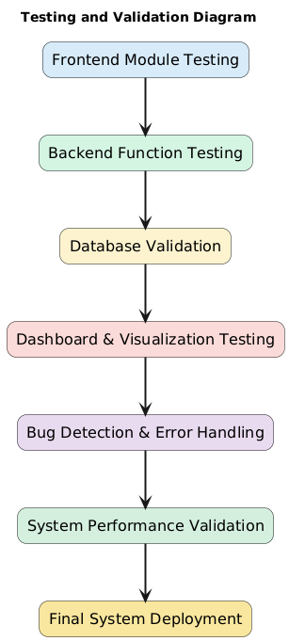
Fig 4.5: Testing And Validation Diagram
Above Figure 4.5 illustrates the testing and validation workflow of the GIDA system. Different modules such as the frontend, backend, database, and dashboard visualizations are tested to ensure proper functionality and accuracy. The system also performs bug detection, error handling, and performance validation before the final deployment of the application. The workflow also includes dashboard and visualization testing for Power BI integration. Interactive charts, graphs, filters, and analytical reports are tested to ensure that visualizations display correct information and update dynamically based on user interaction. Validation is performed to confirm that the dashboard accurately represents the processed economic datasets and generates meaningful analytical insights.
Another important part of the workflow is user interaction testing. Features such as filtering, searching, navigation, and dashboard controls are tested to verify smooth functionality and proper response to user actions. Error handling mechanisms are also checked to ensure system stability and reliability during invalid inputs or unexpected operations.
After testing is completed, validation is performed by comparing analytical outputs with the original datasets and expected results. This helps confirm the accuracy, consistency, and reliability of the information displayed within the system. Any identified issues or inconsistencies are corrected before final deployment of the application.
Overall, the Testing and Validation Workflow helps improve the reliability, accuracy, performance, and usability of the analytics platform. It ensures that all components of the system work together efficiently and provide correct analytical insights for studying global income distribution and economic inequality.
4.10 Overall System Execution Flow
The Overall System Execution Flow of the “Interactive Analytics Dashboard for Global Income Distribution” project explains how different components of the system work together to perform data analysis and visualization operations efficiently. The execution flow begins when economic datasets are collected from reliable sources such as the World Bank, IMF, and OECD. These datasets contain important information related to GDP per capita, income distribution, poverty ratio, Gini Index, and regional economic indicators.
After data collection, the datasets are imported into the backend processing environment developed using Python. During this stage, preprocessing operations such as data cleaning, removal of missing values, duplicate handling, formatting, and normalization are performed using Python libraries such as Pandas and NumPy. These preprocessing steps help improve data consistency and analytical accuracy before further processing.
Once the datasets are cleaned and organized, the processed information is stored in the SQLite database. The database manages data storage, retrieval, and organization efficiently, allowing the backend system to access the required information whenever users perform analytical operations within the platform.
When a user accesses the web application, the frontend interface developed using HTML, CSS, and JavaScript loads the dashboard environment and visualization components. Users can interact with the system through filters, search options, and dashboard controls to select countries, regions, years, or economic indicators according to their analytical requirements.
The frontend sends user requests to the backend processing system, where Python retrieves the required data from the SQLite database and processes it according to the selected filters and analytical parameters. The processed information is then integrated with Power BI dashboards to generate interactive charts, graphs, comparative reports, and analytical visualizations.
The Power BI dashboards display the generated analytical insights within the web application, allowing users to study income distribution patterns, compare economic conditions, and analyze global financial trends interactively. Whenever users apply new filters or modify analytical selections, the system dynamically updates the visualizations and displays refreshed analytical results in real time.
The overall execution flow ensures smooth communication between frontend modules, backend processing, database operations, and visualization components. This structured workflow improves system performance, analytical accuracy, and user experience while supporting efficient analysis of global income distribution through a full-stack web-based analytics platform.

Chapter 5
User Interface & Project Experience
The “Interactive Analytics Dashboard for Global Income Distribution” project includes a responsive and user-friendly web interface designed to provide smooth interaction and easy access to analytical features. The user interface plays an important role in improving user experience by presenting dashboards, reports, filters, and analytical tools in an organized and visually understandable manner. The system is developed using HTML, CSS, and JavaScript to create an interactive frontend environment, while backend processing and database operations are handled using Python and SQLite.
This chapter explains the design and working of different interfaces included in the application such as the Login Page, Home Page, About Page, Dashboard Page, Communication Hub, Chatbot Interface, and Admin Panel. Each interface is developed to perform specific functionalities within the system and improve accessibility, navigation, and interaction for users. Power BI dashboards are integrated into the platform to provide interactive visualization and business intelligence analytics through charts, graphs, and comparative reports.
The chapter also describes how users interact with the system, apply filters, analyze economic data, and generate visual insights using the dashboard environment. In addition to interface design and functionality, this chapter includes the challenges faced during project development, practical learning outcomes, project contributions, and overall internship experience gained while developing the full-stack analytics platform.
5.1 Introduction to User Interface
The user interface of the “Interactive Analytics Dashboard for Global Income Distribution” project is designed to provide a simple, interactive, and user-friendly environment for accessing analytical features and visual dashboards. A well-designed user interface is important because it improves user interaction, simplifies navigation, and helps users understand complex economic data more easily through organized visual representation.
The frontend of the application is developed using HTML, CSS, and JavaScript to create responsive and interactive web pages. HTML is used to structure the different sections of the website, CSS improves the visual appearance and responsiveness of the interface, while JavaScript provides dynamic interaction and smooth user experience. The interface is designed in a way that users can easily navigate through different pages such as Login Page, Home Page, About Page, Dashboard Page, Feedback Page, Chatbot Interface, and Admin Panel.
The user interface focuses on improving accessibility and usability by providing organized layouts, interactive controls, responsive dashboards, and easy-to-use navigation systems. Users can interact with the dashboard through filters, search options, charts, and analytical reports without requiring advanced technical knowledge. The integration of Power BI dashboards within the interface helps users analyze global income distribution data through interactive charts, graphs, and comparative visualizations.
Another important aspect of the user interface is responsive design. The application is designed to work smoothly across different devices and screen sizes, ensuring better accessibility and improved user experience. Navigation menus, visualization panels, and dashboard components are arranged systematically to provide a clean and professional appearance within the application.
Overall, the user interface of the system provides a modern and interactive environment that improves data accessibility, visualization clarity, and analytical understanding. It plays an important role in enhancing user experience and supporting efficient interaction with the full-stack analytics platform.
5.2 Login Interface
The Login Interface of the “Interactive Analytics Dashboard for Global Income Distribution” project is designed to provide secure and organized access to the web application for both normal users and administrators. The interface is developed using HTML, CSS, and JavaScript to create a responsive and visually attractive login system with smooth user interaction and modern design elements. The login page acts as the entry point of the application and ensures that only authenticated users can access the dashboard and analytical functionalities of the system.
The login interface includes two separate authentication sections: User Login and Admin Login. The User Login section is designed for general users who want to access the analytics dashboard and explore global income distribution data through interactive visualizations and reports. Users can enter their email address and password in the login form to authenticate themselves within the system. The interface also includes options for account registration, allowing new users to create accounts and access the platform easily.
The Admin Login section is designed specifically for authorized administrators who manage system operations and administrative functionalities. This section provides restricted access to sensitive system controls and management features. Administrators are required to enter valid credentials before accessing the admin panel. The separate admin authentication system improves security and helps maintain proper access control within the application.
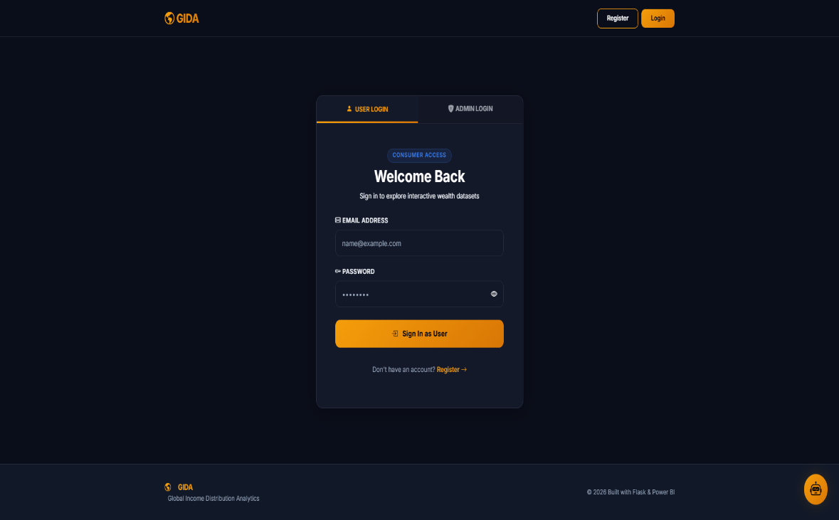
Fig 5.1: Login Page
Above figure 5.1 shows the login interface of the GIDA system. The page allows users and administrators to securely access the platform using their email and password. It provides authentication functionality for accessing dashboards, analytics features, and other system modules. The interface uses a modern dark-themed design with highlighted buttons, structured login forms, and organized layout components to improve visual appearance and user experience. Responsive frontend design techniques ensure that the login page works smoothly across different screen sizes and devices. Interactive form elements and validation controls further improve usability and make the authentication process easier for users.
Backend authentication operations are implemented using Python, while SQLite is used for storing and validating user credentials securely. When users enter login details, the backend system verifies the credentials with database records and grants access only if the information is correct. Error handling and validation mechanisms are also included to prevent unauthorized access and improve system reliability.
The login interface plays an important role in improving system security, user management, and controlled access to the analytics platform. It provides a professional and user-friendly authentication environment that supports both normal user operations and administrative system management within the full-stack analytics web application.
5.3 Home Page Interface
The Home Page Interface of the “Interactive Analytics Dashboard for Global Income Distribution” project serves as the main landing page of the web application after successful user login. The home page is designed to provide users with an overview of the platform, quick navigation to important sections, and introductory information related to global income distribution analytics. The interface is developed using HTML, CSS, and JavaScript to create a responsive, modern, and interactive user experience.
The top section of the homepage contains a navigation bar that allows users to access different sections of the application such as Home, About, Dashboard, and Feedback pages. The navigation system is designed in a simple and organized manner so that users can move between different functionalities of the platform easily. A user profile icon is also included in the navigation area to improve personalization and user accessibility within the system.
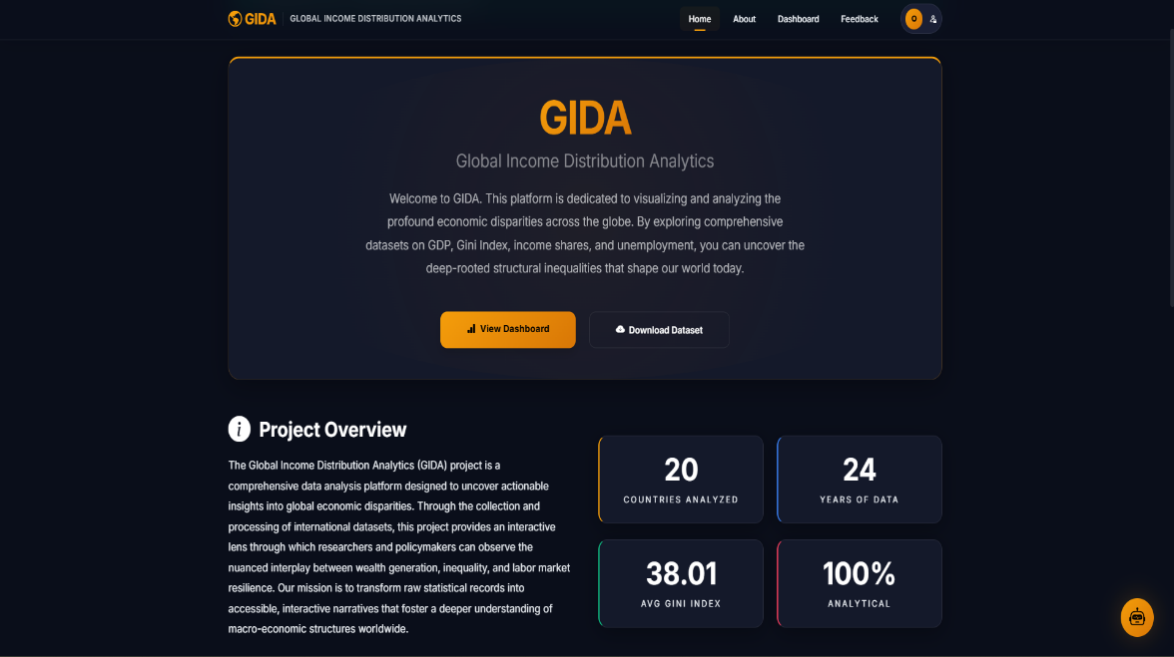
Fig 5.2: Home page
Above Figure 5.2 shows the homepage interface of the GIDA system, which provides an overview of global income distribution analytics along with quick access to dashboards, datasets, and key economic statistics. The main banner section of the homepage introduces the GIDA (Global Income Distribution Analytics) platform and explains the purpose of the project. This section provides a brief overview of how the system helps visualize and analyze global economic disparities using interactive datasets and analytical dashboards. Action buttons such as “View Dashboard” and “Download Dataset” are provided to help users quickly access analytical reports and datasets from the homepage itself.
Another important section of the homepage is the “Project Overview” area, which explains the objective and functionality of the analytics platform. This section describes how the system processes global economic datasets and transforms them into interactive visual insights for researchers, analysts, and users interested in studying economic inequality and financial distribution patterns.
The homepage also includes statistical information cards that display key analytical highlights such as the number of countries analyzed, years of data covered, average Gini Index, and overall analytical coverage of the system. These information cards improve the visual presentation of important project statistics and provide users with a quick understanding of the dataset and analytical scope of the platform.
Another major section of the homepage is the “Detailed Inequality Analysis” area, where important economic indicators such as GDP Per Capita, Gini Index, Income Share, and Unemployment Rate are explained. Each indicator is presented using structured information cards that include definitions, units, significance, and analytical descriptions. This section helps users understand the meaning and importance of different economic indicators used within the analytics dashboard.
The homepage further includes a “Global Insights” section that highlights important analytical observations and findings generated from the datasets. This section presents key insights related to wealth polarization, inequality patterns, and labor market conditions across different countries and regions. These insights help users understand global economic disparities in a more simplified and meaningful way.
The interface follows a modern dark-themed design with responsive layouts, organized sections, highlighted buttons, and visually attractive analytical cards. CSS styling improves the professional appearance of the homepage, while JavaScript supports dynamic interaction and smooth navigation between different components of the interface.
Overall, the Home Page Interface provides an interactive and informative environment that introduces users to the analytics platform and improves accessibility to dashboards, datasets, and analytical features. It plays an important role in enhancing user experience, simplifying navigation, and presenting economic information in a visually understandable manner within the full-stack analytics web application.
5.4 About Page Interface
The About Page Interface of the “Interactive Analytics Dashboard for Global Income Distribution” project is designed to provide detailed information about the purpose, objectives, analytical concepts, and importance of the GIDA platform. This page helps users understand the background of the project, the problem of global income inequality, and the significance of data-driven analysis in studying economic disparities across different countries and regions. The interface is developed using HTML, CSS, and JavaScript to create a visually attractive and informative user experience.
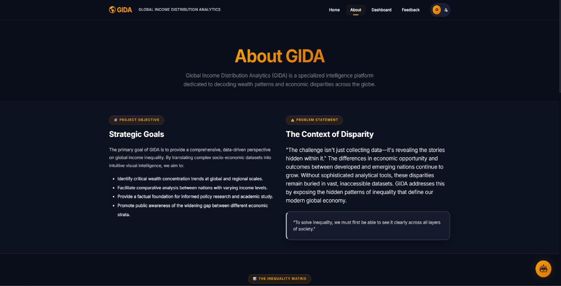
Fig 5.3: About Page
Above Figure 5.3 shows the About page interface of the GIDA system, which explains the project objectives, global economic inequality issues, and the importance of analytical insights in understanding income distribution patterns. The top section of the About page introduces the GIDA platform and explains its role as a specialized analytics system focused on studying global income distribution and economic inequality. This section provides a brief overview of how the platform transforms complex socio-economic datasets into understandable analytical insights using visualization and interactive reporting techniques.
Another important section of the interface is the “Project Objective” area, where the strategic goals of the platform are explained. This section describes how the system aims to identify global wealth concentration trends, support comparative economic analysis, improve awareness regarding inequality, and provide useful insights for research and policy understanding. The content is organized in a structured format using bullet points and descriptive text to improve readability and user understanding.
The page also includes a “Problem Statement” section that explains the challenges related to analyzing economic inequality using traditional methods. It highlights how important financial disparities often remain hidden inside large datasets and how advanced analytical tools are required to uncover meaningful patterns and economic trends. This section helps users understand the motivation behind the development of the GIDA analytics platform.
Another major part of the About page is the “Analyzing Global Income Landscapes” section, which explains different aspects of global inequality such as the global wealth gap, Gini coefficient metrics, middle-class squeeze, and regional disparities. Each concept is presented through separate information cards with descriptive explanations, making the analytical content easier to understand and visually organized for users.
The interface further includes the “Structural Patterns of Disparity” section, where factors contributing to inequality are explained. Topics such as wealth concentration, demographic gaps, urban-rural divide, and economic mobility are discussed in detail. Alongside this, the “Driving Factors” section explains how automation, globalization, policy frameworks, and education access influence income inequality and wealth distribution across societies.
Another informative section of the page is “Why Analytical Data Matters,” which emphasizes the importance of data analytics and visualization in understanding global economic conditions. This section explains how analytical insights help transform raw economic records into meaningful social understanding and informed decision-making. The interface also includes conceptual explanations such as the “Ladder Analogy” to simplify complex economic concepts and make the information more understandable for users.
5.5 Dashboard Interface
The Dashboard Interface is the main analytical component of the “Interactive Analytics Dashboard for Global Income Distribution” project. This interface is designed to provide interactive visualization, comparative analysis, and detailed insights related to global income distribution and economic inequality. The dashboard integrates Power BI visualizations within the web application and allows users to analyze large economic datasets through charts, graphs, maps, filters, and KPI indicators in an organized and user-friendly manner.
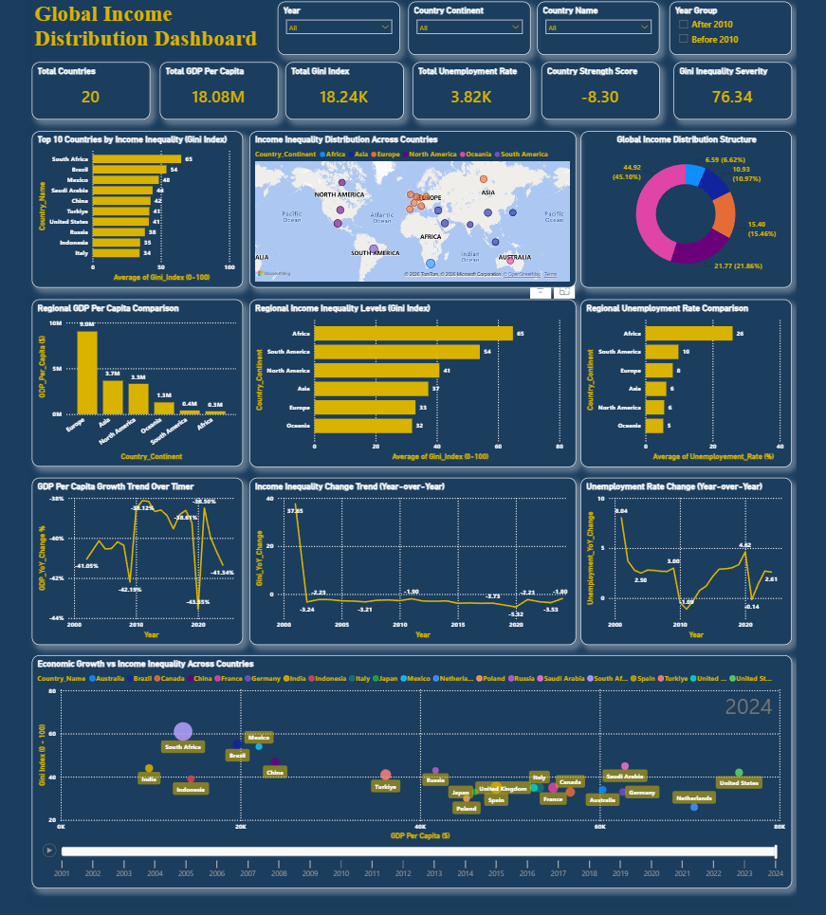
Fig 5.4: Dashboard Interface
Above Figure 5.4 shows the interactive dashboard interface of the GIDA system, which presents global income distribution data using KPI cards, charts, graphs, maps, and country comparison analytics for better economic insight and visualization.
The top section of the dashboard includes a “Quick Start Guide” that helps users understand how to use the analytical platform effectively. This section explains the basic workflow of the dashboard, including filtering observations, analyzing key metrics, and exploring detailed analytical insights. It improves accessibility for new users and simplifies interaction with the dashboard system.
The main dashboard area contains multiple interactive filters and slicers such as Year, Country Continent, Country Name, and Year Group. These filters allow users to customize analytical reports according to specific countries, regions, or time periods. Once users apply filters, the dashboard updates dynamically and displays customized visualizations based on the selected data. This dynamic filtering functionality improves flexibility and enhances analytical exploration.
The dashboard also includes several KPI cards that display important statistical indicators such as Total Countries, Total GDP Per Capita, Total Gini Index, Total Unemployment Rate, Country Strength Score, and Gini Inequality Severity. These KPI cards provide quick analytical summaries and help users understand overall economic conditions directly from the dashboard interface.
Different graphical visualizations are integrated within the dashboard to represent economic data in a meaningful and visually understandable format. Bar charts are used to display the top countries with the highest income inequality based on the Gini Index. Regional comparison charts are included to compare GDP per capita, unemployment rates, and inequality levels across different continents and economic regions.
The dashboard additionally includes a world map visualization that displays income inequality distribution across countries globally. This map helps users identify regional patterns and geographical concentration of economic disparities through interactive visual representation. Pie charts and donut charts are also used to show global income distribution structures and percentage-based financial segmentation among different population groups.
Line graphs and trend analysis charts are included to study changes in GDP growth, unemployment rates, and income inequality over different years. These trend visualizations help users understand long-term economic patterns and observe how inequality changes over time. Animated comparison charts further improve analytical depth by allowing users to compare GDP and Gini Index relationships among countries across different years.
Another important functionality of the dashboard is the country comparison feature. Users can select two countries and compare economic indicators such as GDP per capita, Gini Index, unemployment rate, income share distribution, and middle-class share side-by-side. This comparison system improves comparative analysis and helps users identify economic differences between countries more effectively.
The dashboard interface also includes an analytics guide section that explains the purpose and functionality of different dashboard components, KPI indicators, charts, and visualization elements. Frequently Asked Questions (FAQ) sections are provided at the bottom of the dashboard to help users understand important analytical concepts and dashboard-related queries more easily.
The interface follows a modern dark-themed design with responsive layouts, highlighted analytical cards, interactive controls, and visually organized sections. HTML, CSS, and JavaScript are used to create the frontend structure and user interaction, while Python backend processing and SQLite database management support data retrieval and analytical operations. Power BI integration plays a major role in generating interactive charts, maps, reports, and business intelligence visualizations within the dashboard environment.
Overall, the Dashboard Interface provides a complete analytical environment for studying global income distribution and economic inequality through interactive visualization, dynamic filtering, comparative analytics, and business intelligence reporting. It improves analytical understanding, user interaction, and accessibility while simplifying complex economic analysis through graphical representation and full-stack web integration.
5.6 Communication Hub / Feedback Interface
The Communication Hub / Feedback Interface of the “Interactive Analytics Dashboard for Global Income Distribution” project is designed to improve interaction between users and the analytics platform management team. This interface allows users to share suggestions, submit feedback, report issues, and request new features directly through the web application. The feedback system helps improve user engagement and supports continuous enhancement of the platform based on user opinions and requirements.
The interface contains a dedicated feedback form where users can select different feedback categories such as General Feedback, Suggestions, Feature Requests, and Bug Reports. This categorization system helps organize user responses properly and allows administrators to manage different types of requests more efficiently. Users can enter detailed messages describing their suggestions, issues, or feedback related to the platform and submit them directly through the interface.
The feedback page also includes a platform rating system that allows users to provide ratings based on their experience while using the analytics platform. This functionality helps evaluate user satisfaction and supports overall system improvement through user reviews and performance feedback.
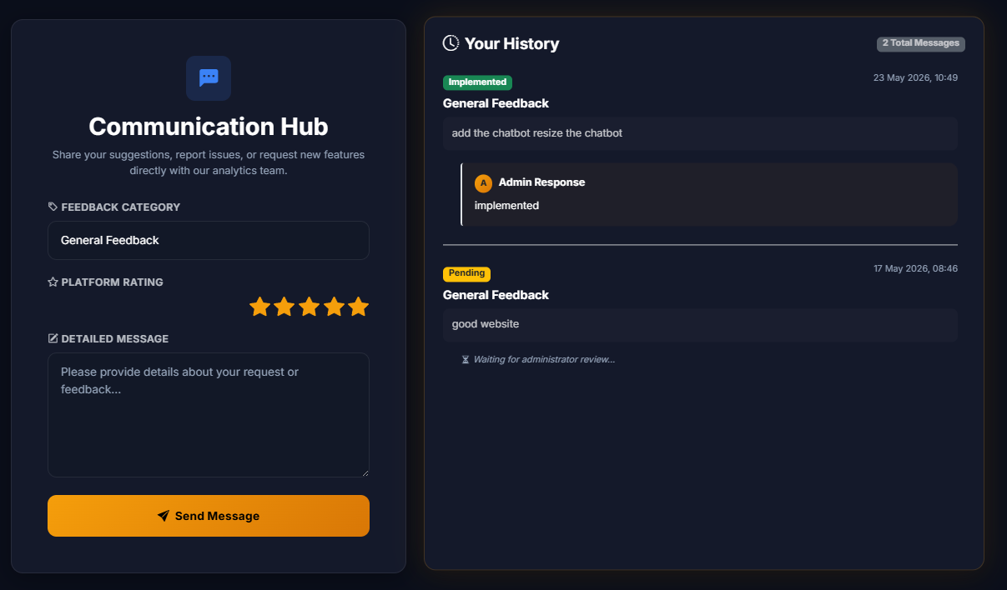
Fig 5.5: Feedback Page
Above Figure 5.5 shows the Communication Hub interface of the GIDA system, where users can submit feedback, provide platform ratings, and communicate suggestions or issues directly to the admin while also viewing response history and feedback status. Another important feature of the Communication Hub is the “Your History” section, where users can view previously submitted feedback and track their response status. The system displays different feedback states such as Pending and Implemented, allowing users to understand whether their requests have been reviewed or processed by the administration team. This improves transparency and enhances communication between users and system administrators.
The interface additionally supports administrator responses, where admins can reply to user feedback and provide updates regarding implemented suggestions or issue resolutions. This creates a structured communication workflow and improves interaction within the platform.
The Communication Hub is developed using HTML, CSS, and JavaScript to provide a responsive and visually organized user interface. The modern dark-themed design, highlighted input sections, and interactive controls improve usability and create a professional appearance. Backend processing using Python handles feedback submission, validation, and communication with the SQLite database, where feedback records and user messages are stored securely.
5.7 Chatbot Interface
The Chatbot Interface of the “Interactive Analytics Dashboard for Global Income Distribution” project is designed to provide intelligent and interactive assistance to users while exploring economic data and analytical dashboards. The chatbot acts as an AI-based virtual assistant that helps users understand economic concepts, retrieve analytical information, and interact with the platform more efficiently. This feature improves user engagement and simplifies access to important analytical insights within the system.
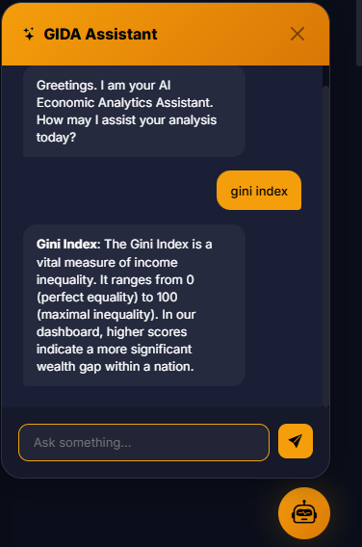
Fig 5.6: Chatbot Interface
Above Figure 5.6 shows the AI chatbot interface of the GIDA system, which allows users to ask economic and analytical questions and receive instant responses related to income inequality, GDP, Gini Index, and other global economic insights.
The chatbot interface is integrated directly into the web application and is accessible through a floating chatbot icon available on different pages of the platform. When users open the chatbot window, they can interact with the GIDA Assistant through a conversational interface designed using HTML, CSS, and JavaScript. The interface follows a modern dark-themed design with organized message sections, interactive controls, and responsive layout elements to improve usability and user experience.
The chatbot initially greets users and introduces itself as an AI Economic Analytics Assistant. Users can type questions related to economic indicators, dashboard metrics, income inequality concepts, GDP analysis, and other analytical topics directly into the chat input section. The chatbot processes the queries and returns relevant responses in a conversational format.
The chatbot is capable of explaining important economic concepts such as the Gini Index, GDP Per Capita, unemployment rates, and income distribution. For example, users can ask questions like “What is Gini Index?” or “Highest GDP in 2011,” and the chatbot provides descriptive analytical answers based on the available dataset and dashboard information. This functionality helps users understand complex economic concepts more easily without manually searching through dashboard reports.
The interface also supports real-time interaction, where user messages and chatbot responses are displayed dynamically within the chat window. Smooth conversation flow and organized message bubbles improve readability and make the chatbot interaction more natural and user-friendly.
Backend processing implemented using Python handles user query processing, response generation, and communication with analytical data sources. The chatbot system is integrated with the overall analytics platform and can retrieve relevant information from datasets and dashboard components to generate meaningful responses. Frontend technologies such as JavaScript help manage dynamic updates and interactive chat functionality within the interface.
5.8 Admin Panel Interface
The Admin Panel Interface of the “Interactive Analytics Dashboard for Global Income Distribution” project is designed to provide complete administrative control over the platform. This interface allows authorized administrators to monitor user activity, manage system records, analyze platform engagement, and respond to user feedback efficiently. The admin panel plays an important role in maintaining platform security, monitoring performance, and improving communication between users and administrators.
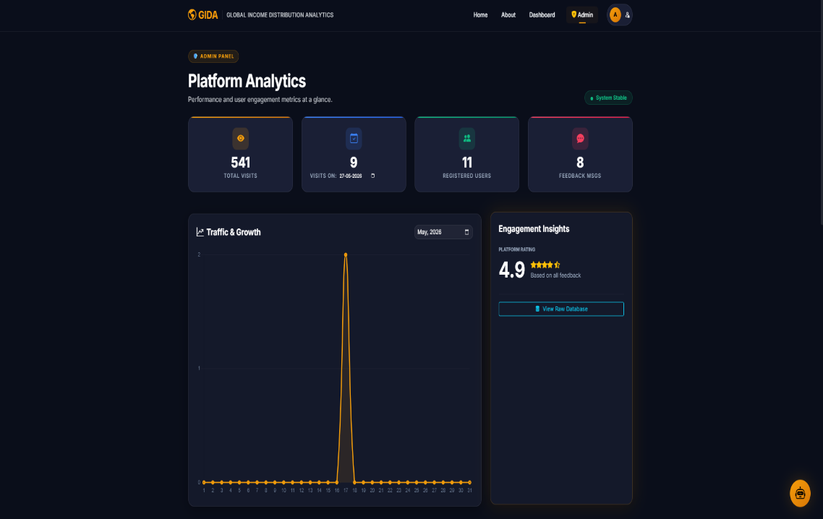
Fig 5.7: Admin Panel
Above Figure 5.7 shows the admin panel analytics interface of the GIDA system, which allows administrators to monitor platform performance, user activity, visitor statistics, and feedback insights through interactive analytical dashboards and reports. The admin dashboard follows a professional dark-themed interface consistent with the overall design of the GIDA platform. The interface contains multiple management sections including platform analytics, database monitoring, user management, visitor tracking, and feedback administration. All components are arranged in a structured manner to help administrators quickly access important information and perform system operations smoothly.
The first section of the admin panel displays platform analytics and system statistics. This section includes KPI cards showing total website visits, active users, feedback messages, and daily platform engagement statistics. These analytical cards help administrators monitor the overall usage and performance of the system in real time. A traffic and growth chart is also included to visualize visitor activity trends over time, helping administrators analyze user engagement patterns and platform growth.
Another important component of the admin panel is the SQLite Database Viewer. This section provides administrators with direct access to internal database records stored within the system. The interface displays tables containing registered users, feedback messages, and visitor logs. Information such as usernames, email addresses, registration timestamps, visit dates, and submitted feedback messages can be viewed in an organized tabular format. This functionality helps administrators monitor database activity and verify stored records efficiently.
The User Account Management section allows administrators to manage platform users and monitor account activity. User details such as registration date, profile information, email addresses, and account status are displayed in a structured table format. The system also provides account security management features, where administrators can monitor active accounts and restrict suspicious or unauthorized users if necessary. This improves system security and helps maintain proper access control within the platform.
The User Communication History section is designed to manage user feedback and communication records. This interface displays submitted feedback messages along with user details, ratings, feedback categories, timestamps, and current response status. Administrators can search and filter communication records using integrated search functionality and status filters. This helps organize large amounts of user feedback efficiently.
An important feature of the admin panel is the reply and status management system. Administrators can directly respond to user feedback through a popup response interface. The system allows administrators to type responses, review submitted messages, and update feedback status values such as “Pending,” “Reviewed,” or “Implemented.” This two-way communication mechanism improves interaction between users and administrators while ensuring proper issue tracking and feedback resolution.
The admin interface also supports platform monitoring and maintenance operations. By analyzing visitor statistics, engagement trends, and user responses, administrators can identify areas requiring improvement and make better decisions for enhancing platform performance and user satisfaction. The integration of analytics and database management within a single interface reduces manual workload and improves operational efficiency.
Backend functionality for the admin panel is implemented using Python and Flask, while frontend components are developed using HTML, CSS, and JavaScript. SQLite is used for managing system records including users, visitor logs, and feedback data. Secure role-based authentication mechanisms ensure that only authorized administrators can access sensitive management functionalities.
Overall, the Admin Panel Interface provides a centralized management environment for controlling and monitoring the entire analytics platform. It improves administrative efficiency, enhances system security, supports feedback management, and enables effective monitoring of platform performance and user interaction within the “Interactive Analytics Dashboard for Global Income Distribution” project.
5.9 Working of the Website
The working of the “Interactive Analytics Dashboard for Global Income Distribution” website begins with user authentication, where users securely log in to access the analytical platform. After successful login, users are redirected to the home page, which provides an overview of the project, economic insights, and navigation to different modules of the system.
The website allows users to explore global economic inequality data through an interactive dashboard integrated with Power BI visualizations. Users can apply filters such as country, continent, year, and year group to dynamically analyze specific datasets. Based on user selections, charts, graphs, KPI cards, maps, and comparison reports are updated in real time to provide meaningful analytical insights.
The system also includes additional modules such as the About page, Feedback and Communication Hub, AI-powered chatbot assistant, and Admin Panel. Users can submit feedback, communicate with administrators, and interact with the chatbot to understand economic concepts and retrieve analytical information quickly.
Administrators can monitor platform activity, manage users, analyze visitor statistics, and respond to user feedback through the admin interface. The backend processes user requests, database operations, and dashboard integration using Flask and SQLite, while the frontend handles user interaction through HTML, CSS, and JavaScript.
Overall, the website works as a complete full-stack analytical platform that combines data processing, interactive visualization, communication features, and administrative management to provide an efficient and user-friendly environment for analyzing global income distribution and economic inequality.
5.10 Project Contribution
During the development of the “Interactive Analytics Dashboard for Global Income Distribution” project, significant contributions were made in multiple areas including frontend development, backend integration, database management, dashboard implementation, and user interaction design. The project involved the complete development of a full-stack analytical web application focused on visualizing and analyzing global economic inequality data.
One of the major contributions was the design and development of the website interface using HTML, CSS, and JavaScript. Multiple responsive pages such as the Login Page, Home Page, About Page, Dashboard Page, Feedback Page, Chatbot Interface, and Admin Panel were created with a modern and interactive user interface. Special attention was given to improving user experience through structured layouts, dark-themed design elements, animations, navigation systems, and responsive components.
Another important contribution was backend development using Python and Flask. Backend functionalities such as user authentication, session management, routing, database communication, chatbot processing, feedback handling, and admin operations were implemented successfully. Secure login systems for both users and administrators were developed to ensure proper access control and system security.
The project also included database management using SQLite, where tables for users, feedback messages, visitor logs, chatbot interactions, and system records were created and maintained. Database integration allowed smooth data storage, retrieval, and processing throughout the platform.
A major contribution was the integration of Power BI dashboards into the web application. Interactive visualizations including KPI cards, bar charts, line graphs, donut charts, maps, trend analysis graphs, and country comparison reports were designed to provide detailed analytical insights related to global income distribution and inequality. Dynamic filtering and real-time data interaction features were also implemented to improve analytical flexibility.
Another valuable contribution was the development of the AI-powered chatbot assistant. The chatbot was integrated into the platform to help users understand economic concepts, answer analytical queries, and improve overall accessibility of the system.
The feedback and communication system was also developed as part of the project contribution. This module enabled users to submit suggestions, feature requests, and issue reports while allowing administrators to respond and manage communication records effectively.
In addition to technical development, the project also involved dataset collection, preprocessing, cleaning, and analysis. Economic datasets containing GDP, Gini Index, unemployment rate, and income share information were organized and prepared for visualization and analytical processing.
Overall, the project contribution involved complete participation in the design, development, integration, testing, and deployment of the analytics platform. The experience helped strengthen practical knowledge in full-stack web development, data analytics, dashboard visualization, database management, and real-world software development practices.
5.11 Overall Internship Experience
The overall internship experience while working on the “Interactive Analytics Dashboard for Global Income Distribution” project was highly informative, practical, and technically enriching. This internship provided an opportunity to work on a real-world full-stack web application that combined data analytics, visualization, backend development, and user interaction within a single platform.
During the internship period, valuable experience was gained in frontend development using HTML, CSS, and JavaScript, where responsive and interactive web interfaces were designed for multiple modules of the system. Working on user-centered interface development improved understanding of website structure, UI/UX principles, responsive layouts, and modern web design practices.
The internship also provided practical exposure to backend development using Python and Flask. Different backend functionalities such as authentication systems, session handling, database connectivity, feedback processing, chatbot integration, and admin management were implemented. This helped improve programming logic, problem-solving skills, and understanding of server-side application development.
Another important learning experience was working with SQLite databases for storing and managing system records. Knowledge related to database design, query execution, data handling, and integration with web applications was strengthened during the development process.
One of the most valuable aspects of the internship was the integration of Power BI dashboards into the web application. This improved understanding of data visualization techniques, business intelligence concepts, and interactive analytical reporting. Creating dynamic charts, KPI cards, maps, and comparison reports helped develop analytical thinking and practical knowledge in data-driven decision-making systems.
The internship also improved teamwork, communication, and project management skills. While developing different modules of the project, various technical challenges such as frontend responsiveness, dashboard embedding, database handling, and user interaction management were encountered and resolved through continuous learning and experimentation. These challenges helped build confidence and improved debugging and troubleshooting abilities.
Working on the AI chatbot and feedback communication system also provided exposure to interactive system design and user engagement features. This enhanced understanding of how intelligent support systems can improve accessibility and user experience within analytical platforms.
Overall, the internship experience was extremely beneficial in bridging the gap between academic learning and practical software development. It provided hands-on exposure to full-stack web technologies, analytical dashboard development, database management, and real-world project implementation. The experience helped improve technical skills, analytical thinking, creativity, and professional confidence, making it a highly valuable learning journey.

Conclusion
The “Interactive Analytics Dashboard for Global Income Distribution” project was successfully designed and developed as a full-stack analytical web application focused on understanding and visualizing global economic inequality. The project combined modern web technologies, database management, business intelligence tools, and interactive user interfaces to create a complete platform for economic data analysis and visualization.
Through this project, global datasets related to GDP Per Capita, Gini Index, unemployment rate, and income distribution were collected, processed, and transformed into meaningful visual insights. The integration of Power BI dashboards helped present complex economic data in a more interactive, understandable, and user-friendly manner. Features such as dynamic filtering, country comparison, trend analysis, chatbot assistance, feedback management, and administrative controls improved the overall functionality and usability of the system.
The project also provided practical exposure to frontend development using HTML, CSS, and JavaScript, backend development using Python and Flask, and database management using SQLite. Modules such as authentication systems, admin management, feedback communication, and AI chatbot integration helped strengthen understanding of full-stack application development and real-world software implementation.
During the internship period, various technical challenges related to data integration, dashboard embedding, and interface responsiveness were successfully resolved. These experiences improved technical skills, problem-solving abilities, teamwork, and overall professional confidence.
Overall, the internship project provided valuable learning experience in web development, data analytics, business intelligence, and system integration while successfully developing an interactive platform for analyzing global income distribution and economic inequality.

References
[1] R. S. Pressman and B. R. Maxim, Software Engineering: A Practitioner’s Approach, 8th ed., New York, NY, USA: McGraw-Hill Education, 2019.
[2] I. Sommerville, Software Engineering, 10th ed., Boston, MA, USA: Pearson Education, 2015.
[3] M. Lutz, Learning Python, 5th ed., Sebastopol, CA, USA: O’Reilly Media, 2013.
[4] A. Downey, Think Python: How to Think Like a Computer Scientist, 2nd ed., Needham, MA, USA: Green Tea Press, 2015.
[5] J. Grayson, Python and SQLite Essentials, Birmingham, UK: Packt Publishing, 2017.
[6] J. Duckett, HTML and CSS: Design and Build Websites, Indianapolis, IN, USA: Wiley, 2011.
[7] J. Duckett, JavaScript and JQuery: Interactive Front-End Web Development, Indianapolis, IN, USA: Wiley, 2014.
[8] E. Freeman, E. Robson, E. Sierra, and B. Bates, Head First HTML and CSS, 2nd ed., Sebastopol, CA, USA: O’Reilly Media, 2012.
[9] R. Nixon, Learning PHP, MySQL & JavaScript: With jQuery, CSS & HTML5, 5th ed., Sebastopol, CA, USA: O’Reilly Media, 2018.
[10] C. D. Manning, P. Raghavan, and H. Schütze, Introduction to Information Retrieval, Cambridge, U.K.: Cambridge University Press, 2008.
[11] S. Few, Information Dashboard Design: Displaying Data for At-a-Glance Monitoring, 2nd ed., Burlingame, CA, USA: Analytics Press, 2013.
[12] W. H. Inmon, Building the Data Warehouse, 4th ed., Indianapolis, IN, USA: Wiley Publishing, 2005.
[13] M. Alexander and J. Walkenbach, Microsoft Power BI Bible, Hoboken, NJ, USA: Wiley, 2020.
[14] G. Harrison and B. Harrison, Practical Tableau: 100 Tips, Tutorials, and Strategies from a Tableau Zen Master, Sebastopol, CA, USA: O’Reilly Media, 2017.
[15] T. H. Davenport and J. G. Harris, Competing on Analytics: The New Science of Winning, Boston, MA, USA: Harvard Business Review Press, 2007.
[16] World Bank, “World Development Indicators,” Washington, DC, USA, 2024.
[17] International Monetary Fund (IMF), “Global Economic Outlook Database,” Washington, DC, USA, 2024.

